Date and Version of the document

Contents

1. Synergita Engage 2
2. Implementation process 2
3. Basic Implementation – Organization & Employee Details 3
4. Continuous Feedback, Rewards and Recognition 8
4.1 E (Mail) – Communication 9
4.2. Culture Score 12
5. Employee Reports 13
6. Continuous Feedback Reports 14
7. Landing Page 15
8. White Listing Email IDs & Access URLs 16

1. Synergita Engage

Synergita engage edition focuses mainly on the employee engagement front. The product includes the basic employee talent information management, rewards & recognition program for employees, continuous feedback to enable continuous conversation and a corporate communication tool for the HR team.
The purpose of the document is to define/collect the requirements to implement Synergita Engage module. It is intended to be a flexible, “living document” and will change and expand throughout the requirements collection phase.

2. Implementation process

Here is a quick view of the implementation activities.

Requirements Collection Process
Implementation team will schedule online meetings with the customers and collect the requirements and data for implementation.
Session | Topics
Session 1 | Employee Talent Information  Continuous Feedback  Rewards & Recognition  Reports
Session 2 | Culture Score  E-Communication

3. Basic Implementation – Organization & Employee Details

Setting up the Organization structure, employee data and group comprise the basic implementation of the product. This basic implementation is applicable for all the editions of the product.
- Company Logo
Share us the company logo to include in the PMS portal. Recommended dimension is 250 px (width) x 100 px (height)
- Employee Data
Employee data can be imported from an Excel file. Basic details like Employee Number, Name, Date of Joining (DOJ), Department, etc., and Personal details like Date of Birth (DOB), Blood Group, Address etc., can be imported together from an excel file into the system.

If you have your employee details in an Excel file (or) can export from your HRIS / ERP software, please send the file to us. We will come back to you with our questions.
- Employee Relationship data (Employee Reporting To details)
Defining Employee Relationship helps to relate an employee within the context of the organizational hierarchy reporting structure. This provides information to employees about who they directly report to based on the organizational hierarchy. At the same time, it also enables the Manager to search for their direct-line reports below. This feature enables to visualize hierarchy structures.

Relationship Name
Manager
Co-Manager (Dotted Line Reporting)
Skip level manager
Function Head/Supervisor

- Department Head details

The organization head (Director, CEO,) HR, Head of HR, department wise head details can be shared which would give a detailed hierarchy structure of an employee in the system.

Department | Department head Employee Name | Department Head Employee Number
Finance
Operations
Business

- Employee Profile
Please tick mark the ones which you want to enable and strike off the ones which you not need to be shown to employees
List of Tabs | View access to be given  ( Employee, Manager, HR) | Edit access to be given  ( Employee, Manager, HR)
Organization
Reporting Structure
Personal Details

Organization
Following are the organization details that can be used. Please strike out the ones which you do not need.

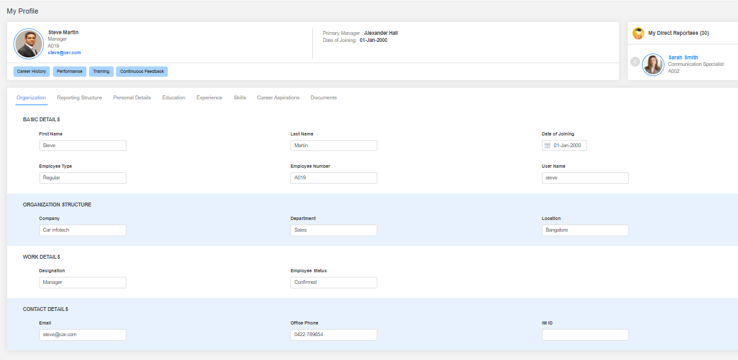
Field Name | Field Name
First Name | Track
Last Name | Employee status
Middle Name | Email
Date of Joining | Contact Number
Employee Type | Work Role
Employee Number | Level/Band
Username | Division
Company
Department
Location
Designation

Personal Details
Do you want to capture personal details in Synergita? (Yes / No)
Following are the Personal details that can be captured in Synergita. Please strike out the ones which you do not need.
Field Name
Gender
Nationality
Date of Birth
Primary Contact Number
Personal Email ID
Current Address
Permanent Address
Blood Group

Employee Attrition Reasons:
Do you keep track of the reasons why your employees are leaving your organization? Yes / No:
If yes, what are the reasons you keep track of and mention the type as well and strike out the ones which you don’t need
Attrition reasons | Type ( Voluntary, Involuntary, Rapid)
Absconding
Attitude
Better opportunity
Disciplinary Action
Higher Education
Marriage
Performance
Relocation
Retirement

(Synergita provides default reasons like Better Opportunity, Performance, etc. This will be useful while generating the attrition report)

4. Continuous Feedback, Rewards and Recognition

The workplace social wall to post appreciations, comments and feedback. Recognize and motivate your friends and colleagues instantly. Present virtual awards and redeemable reward points to your employees.
Exchange continuous feedback and performance conversation with your managers on each of your SMART Goal. It helps you stay focused and proactive in achieving your goals. And you can eliminate the regency effect by referring conversation history during appraisal.
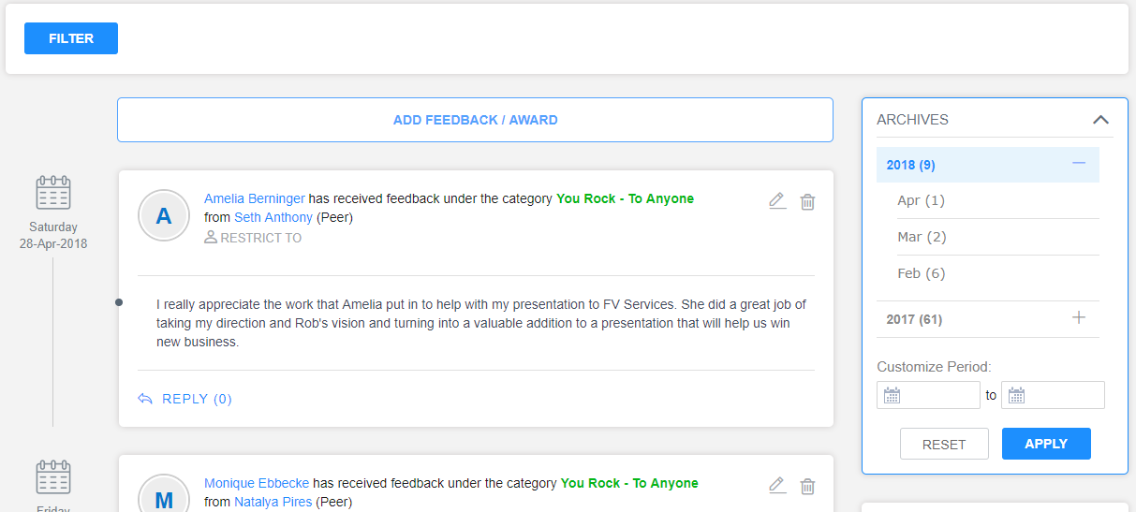
- Categories
Default categories that come along with the software are as follows:
Continuous Feedback Category | Who can provide the feedback? | Who can view the feedback
Appreciation
Area Of Improvement
Confidential notes
Award
One-one meeting

In Synergita, Employees can provide awards or recognitions to each other.
These awards can have points.
Do you have any awards such as employee of the month, spot awards, super sales star, etc. instituted in your organization? YES / NO

If yes, please provide the awards here:
Award Name | Award Image
Employee of the Month | Awardname.Jpg (or) Awardname.png

Note: The maximum Award image dimension supported is 150 px (Width) x 150 px (Height)
If you don’t have any awards instituted and you want to do, please fill the above table and let us know.

4.1 E (Mail) – Communication

E-communication feature enables structured corporate communication across the Organization. Most corporate communication happens via email and this feature allows the HR teams to engage with all the employees through email. HR teams shall send announcements and communication to group of employees.
Here are the benefits:
- Understand the reachability of your emails
- Track the corporate communication history in one place
- Analyze the reachability and email read status
This approach enables HR teams to engage their employees through emails. HRs can compose and send emails from Synergita to the group of employees.

User friendly email editor to compose nice emails; attachments are also supported
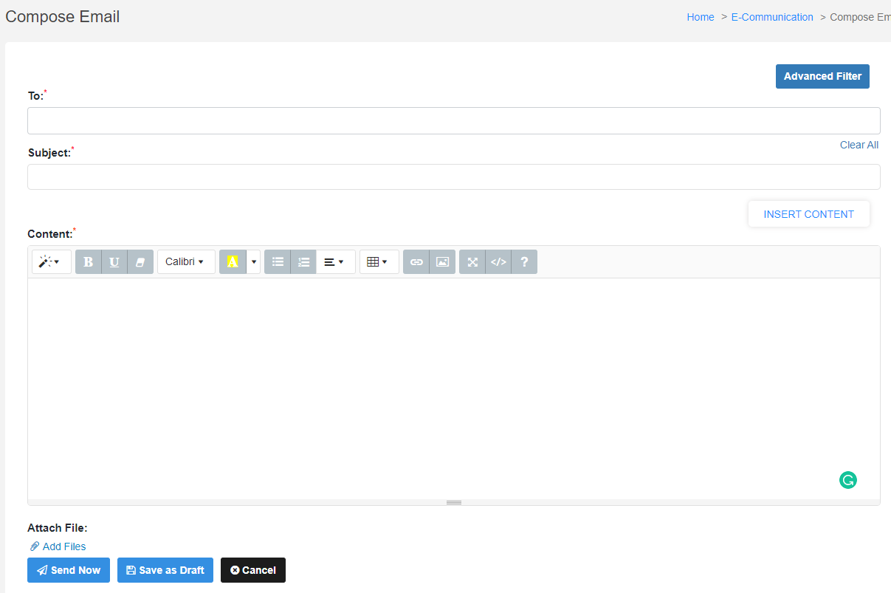
Easily pick-up the recipients from the employee database
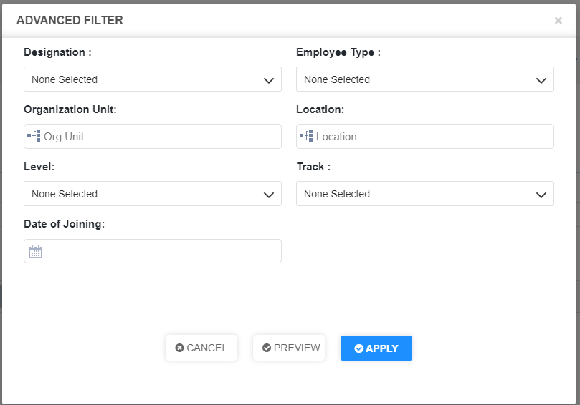
Visual metrics – Analyze the reachability, read status, etc.
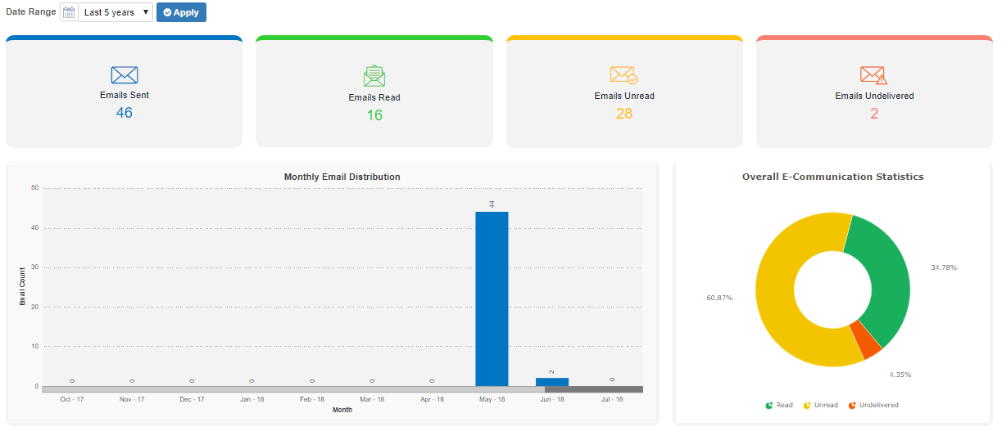

Inputs required for the implementaton:
Input | Default
List of employees, who require access to E-Communication feature | HR Manger

Do you want to enable E-communication feature for your Organization? YES / NO
PS: Your IT team needs to whitelist the email ID notifications@synergita-talentmanagement.com

4.2. Culture Score

Employee performance matters. It’s equally important to ensure that the employees live Organization VALUES such as OPENESS, INNOVATION, FAIRENESS, etc.
Synergita provides a simple and innovative feature to measure core value adherence of employees. Peers can rate how every employee demonstrate the company's core values. The ratings can be given openly or anonymously.
Here are the benefits of this feature:
- Employees can know their adherence level
- Leadership teams / HR teams understand the adherence and identify the gaps to be filled
- Empowers the employees to express themselves
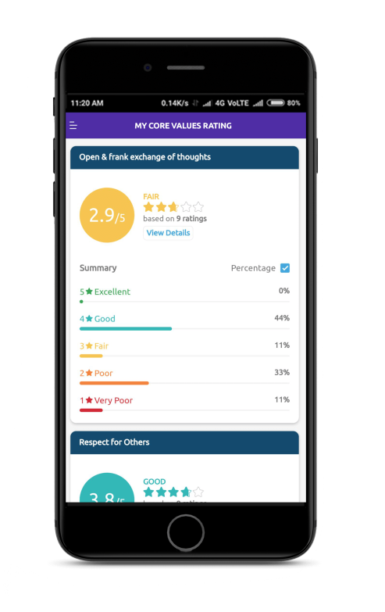
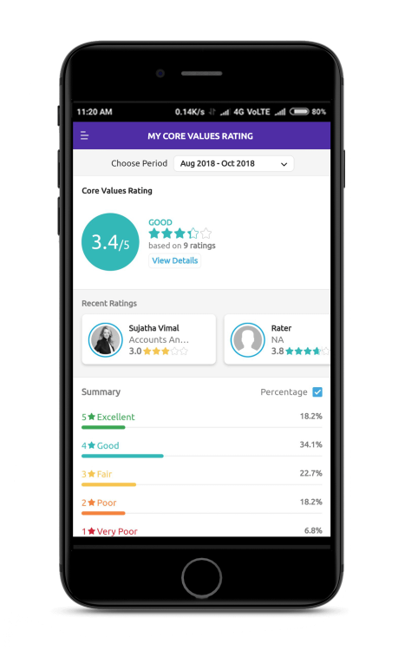
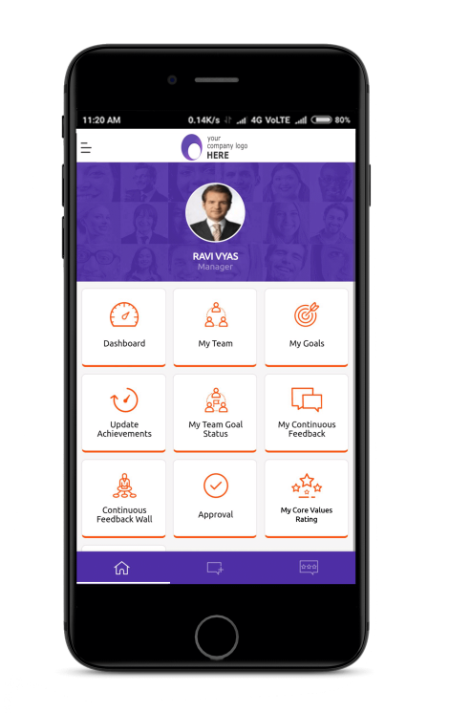

Overall culture score analysis can be tracked in the Mobile app itself.

Inputs required for the implementation
Input | Default
Organization Values | Please list down your Organization values:
List of participating employees by Organization unit, location designation, employee type, employee status & level | Eligible Employees
Rating Scale | Poor – 1  Fair – 2  Good – 3  Excellent – 4
Enable anonymous rating – The rater won’t reveal to employees. HR can still view the raters | Yes/No
Comments – Do you mandate the qualitative comments along with ratings? | Mandatory/Non-Mandatory
Rating calculation frequency – mode for aggregating the cumulative rating. | Quarterly/Annual

5. Employee Reports

Synergita provides extensive reporting capabilities in the form of Dashboards & Reports.
- Easy to understand graphical charts
- The reports can also be easily configured for insights

List of Reports Supported in Synergita:

Name of the report | Access to Roles  ( Manager, HR, Skip Level Manager )
New Hire report
Employee report
Attrition report

6. Continuous Feedback Reports

Continuous Feedback Summary Report provides a summary of the continuous feedback count details of the employees within the organization. This report enables the HR team to glance quickly the continuous feedback count that the employees received by category-wise across the organization in one report thereby saving time and effort.
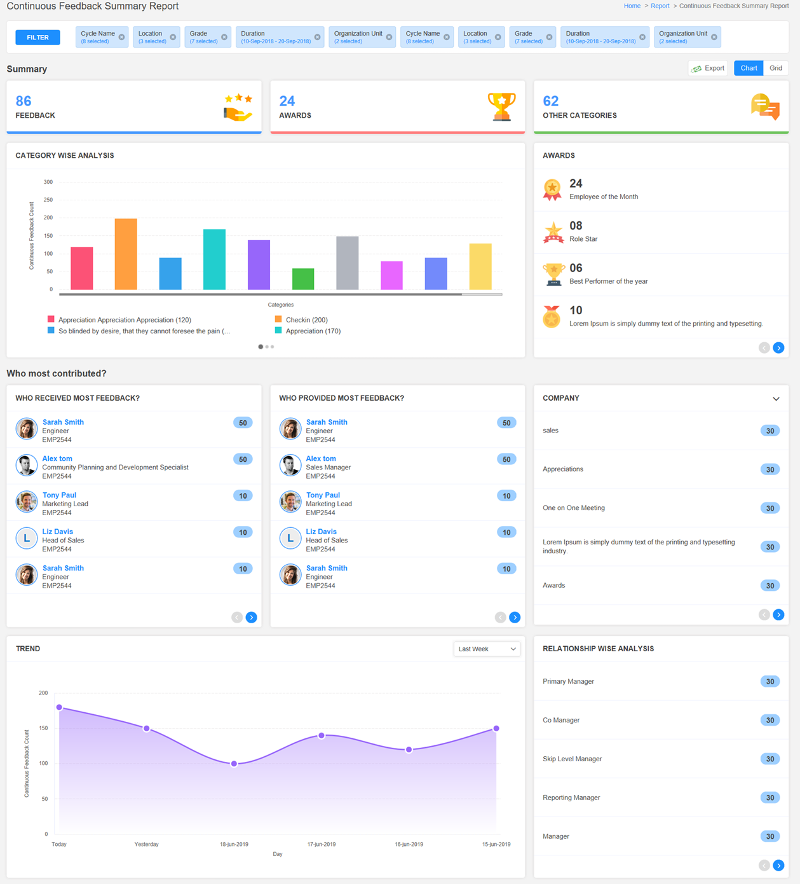

- Also, you can view the summary tables displaying the top count of Award / Continuous Feedback based on Organization unit and the relationships who have posted it.

- AWARDS summary displays the top count of the rewards that the employees received across the organization in an order descending to the least reward count for the past 1 year.
- COMPANY summary displays the top 10 organization units that received the topmost count of continuous feedback for the past 1 year.
- RELATIONSHIP WISE ANALYSIS summary displays the top 10 relationships like peers, manager, or HR or higher authorities who have given the most feedback in large numbers for the past 1 year.

- Who received most feedback? Provides the list of top 10 employees who received the Continuous Feedback the most and who provided most feedback? Provides the list of top 10 relationships or authorities who provided the most Continuous Feedback for the past 1 year.

7. Landing Page

Every user after his/her successful login will land into the home page. The home page can be customized in particular for every customer. The customer need to provide the image and content that has to be displayed in the home/landing page.

- Any announcements (or) welcome note to your organization can be added in the landing page based on your requirement.
- To the left will have the workflow finalized for the organization and to the right the HR team can give announcement about PMS and the heads to the employees about the review process
- This is customizable and below attachment has sample announcement content

8. White Listing Email IDs & Access URLs

Whitelist the following email addresses:

This is to ensure that the email notifications are allowed to your domain. Synergita will send multiple emails to employees in every PMS activity for various activities.
      - support@synergita.com
- notifications@synergita-TalentManagement.com
Whitelist the below IP address as well
IP Addresses
35.154.100.53
52.66.69.252
52.66.52.226
13.126.167.138
35.154.28.139

Also, the following access URLs have to be white listed so that the application is accessible for your employees.

https://<YourOrganizationName>-pms.synergita.com
https://<YourOrganizationName>-pmsstage.synergita.com

Note: Check with your IT team on whitelisting the above IDs.

