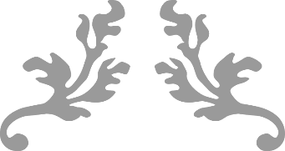
CUSTOMER – employee performance management automation
Project Governance
Date
synergita

Introduction
This document provides high level information for governing the implementation project for automating employee performance management process. These automation projects give lot of insight into the existing manual / Excel based process and opportunities. It also provides opportunity to re-engineer and make the appraisal process better and simpler.
It is important to bring in a structure on the execution and top management involvement during the implementation process.

Project Team Members
Following table provides the details of the project team members. Project team consists of people from Customer & Synergita. Team from customers end will provide all the necessary data for implementation and get trained on the software for administration, user acceptance testing, etc.
Project team will have regular meetings and reach out to each other directly for faster communication and smooth execution of the project.
Name of the team member | Role of the team member | Contact Number | Email Address
Customer
Synergita

Governing Council
Governing council will guide the team on the requirements, take critical decisions on the project, provide necessary approvals, resolve any potential bottlenecks that may arise during the implementation, etc.
Project team will keep the governing council updated with the project progress + give Red/Amber/Green indicators on each activity regularly.
Governing council will also be available throughout the implementation for seeing the demo of the setup.

Name of the team member | Contact Number | Email Address
Customer
Synergita

Escalation Matrix
Just in case if things are not going well, following team members would jump and make sure that the project comes back on track.
Name of the team member | Contact Number | Email Address
Customer
Synergita

High level Project Plan
Step | Responsibility | Target Date
Kick-off Meeting
Employee Data | Customer
Import employee data in Stage Server
Feedback forms & Workflow | Customer
Setup Feedback form & workflow in the software
Training the HR Administrators of Customer | Customer & Synergita
User Acceptance Testing | Customer & Synergita
Go-Live Preparation (Training & internal communication ) | Customer
Go-Live | Customer

Communication Mechanism
We will predominantly use GotoMeeting, Emails and phone for communicating between team members.

