



Date and Version of the document

Contents

**1. Introduction 2**

**2. Implementation plan 2**

**3. Implementation - Organization Structure & Employee Details 3**

**4. Synergita Perform Plus 13**

**4.1 360-degree driven reviews 13**

**4.2 Promotion Cycle 14**

**4.3 Appraisal Letter Distribution 20**

**4.4 HiPo Rating 23**

**5. Development (Employee Training) 25**

**6. Reports 26**

**7. Email & Notification Templates 28**

**8. Landing Page 28**

**9. White Listing Email IDs & Access URLs 29**

**10. Integration & Authentication Types 30**

# 1. Introduction

Synergita perform plus edition focuses on the core features required for managing the employee performance right from goal setting, periodic performance reviews, monitoring the progress on employee goals and so many other features to get insights around employees’ performance across the Organization

The purpose of the document is to define/collect the requirements to implement Synergita’ s Perform Plus module. It is intended to be a flexible, “living document” and will change and expand throughout the requirements collection phase. It is important to first determine what your performance management process will be. Providing the details below will help make your set up into a great one.

# 2. Implementation plan

Here is a quick view of the implementation process.

**Requirements Collection Process**

Implementation team will schedule online meetings with the customers and collect the requirements and data for implementation.

|  |  |
| --- | --- |
| Session Details | Topic |
| Session 1 | Employee Talent Information, Relationship data, Employee Profile Setup, Integration & Authentication |
| Session 2 | 360 degree driven reviews, Promotion Cycle, HiPo Rating, |
| Session 3 | Appraisal letter Distribution, Development (Employee ) |
| Session 4 | Reports and Email Notifications |

# 3. Implementation - Organization Structure & Employee Details

Setting up the Organization structure, employee data and group comprise the basic implementation of the product. This basic implementation is applicable for all the editions of the product.

* **Company Logo**

Share us the company logo to include in the PMS portal. Recommended dimension is 250 px (width) x 100 px (height)

* **Employee Data**

Employee data can be imported from an Excel file. Basic details like Employee Number, Name, Date of Joining (DOJ), Department, etc., and Personal details like Date of Birth (DOB), Blood Group, Address etc., can be imported together from an excel file into the system.

|  |  |
| --- | --- |
|  |  |
| Detailed Version | Minimal version |

**If you have your employee details in an Excel file (or) can export from your HRIS / ERP software, please send the file to us. We will come back to you with our questions**

* **Employee Relationship data (Employee Reporting To details)**

Defining Employee Relationship helps to relate an employee within the context of the organizational hierarchy reporting structure. This provides information to employees about who they directly report to based on the organizational hierarchy. At the same time, it also enables the Manager to search for their direct-line reports below. This feature enables to visualize hierarchy structures.

|  |
| --- |
| Relationship Name |
| Manager |
| Co-Manager (Dotted Line Reporting) |
| Skip level manager |
| Function Head/Supervisor |

* **Department Head details**

The organization head (Director, CEO,) HR, Head of HR, department wise head details can be shared which would give a detailed hierarchy structure of an employee in the system.

|  |  |  |
| --- | --- | --- |
| Department | Department head Employee Name | Department Head Employee Number |
| Finance |  |  |
| Operations |  |  |
| Business |  |  |

* **Employee Profile**



Please tick mark the ones which you want to enable and strike off the ones which you not need to be shown to employees.

|  |  |  |
| --- | --- | --- |
| List of Tabs | View access to be given  ( Employee, Manager, HR) | Edit access to be given  ( Employee, Manager, HR) |
| Organization |  |  |
| Reporting Structure |  |  |
| Personal Details |  |  |
| Travel |  |  |
| Education |  |  |
| Experience |  |  |
| Skills |  |  |
| Career Aspirations |  |  |
| Documents |  |  |

**Organization**

Following are the organization details that can be used. Please strike out the ones which you do not need.

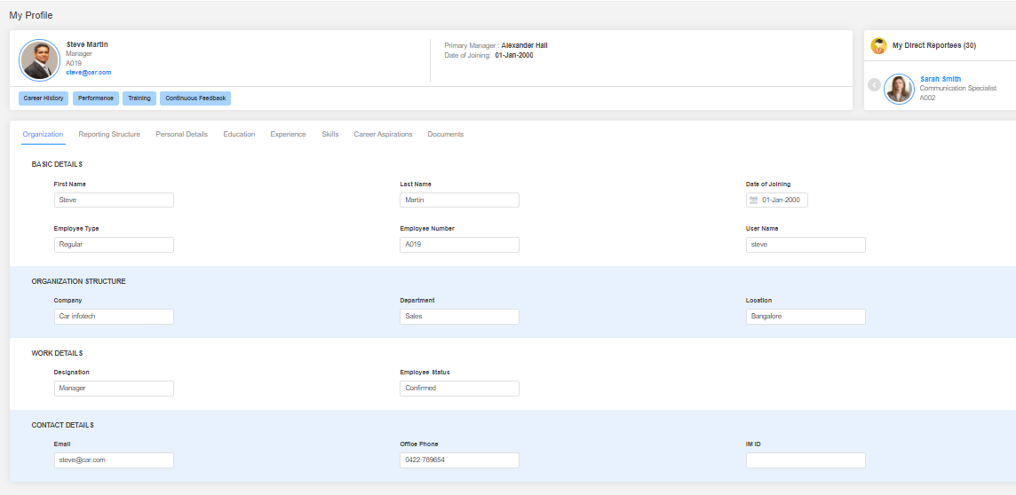

|  |  |
| --- | --- |
| Field Name | Field Name |
| First Name | **Track** |
| Last Name | **Employee status** |
| Middle Name | **Email** |
| Date of Joining | **Contact Number** |
| Employee Type | **Work Role** |
| Employee Number | **Level/Band** |
| Username | **Division** |
| Company |  |
| Department |  |
| Location |  |
| Designation |  |

**Personal Details**

**Do you want to capture personal details in Synergita? (Yes / No)**

Following are the Personal details that can be captured in Synergita. Please strike out the ones which you do not need.

|  |
| --- |
| Field Name |
| Gender |
| Nationality |
| Date of Birth |
| Primary Contact Number |
| Personal Email ID |
| Current Address |
| Permanent Address |
| Blood Group |

**Education Details**

**Do you want to capture educational details? Yes / No**

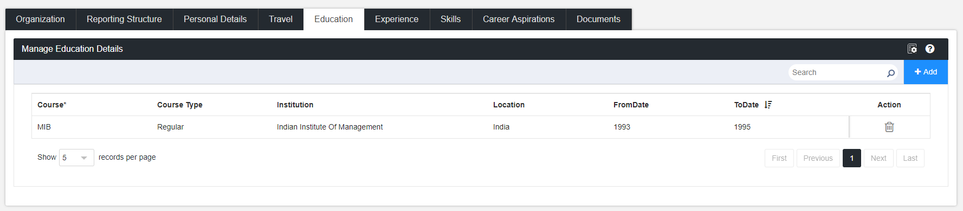

Please strike out the ones which you do not need.

Also, please specify who will have the privileage to edit the information at this page? (Employee, Manager or HR)

|  |
| --- |
| Field Name |
| Course Name |
| Course Type |
| Institution |
| Location |
| From date/To Date |



**Travel (Passport & Workvisa) details**

**Do you want to capture passport and work visa details in Synergita? (Yes / No)**

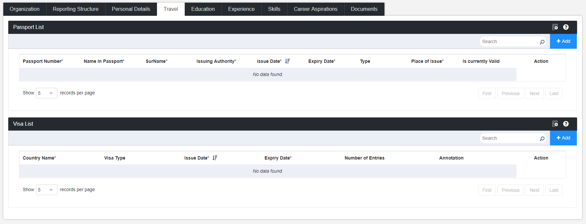

Please strike out the ones which you do not need.

|  |
| --- |
| Field Name |
| Passport Number |
| Name in Passport |
| Issuing Authority |
| Issue Date |
| Expiry Date |

Also, please specify who will have the privileage to edit the information at this page? (Employee, Manager or HR)

**Experience Details**

**Do you want to capture experience details in Synergita? (Yes / No)**

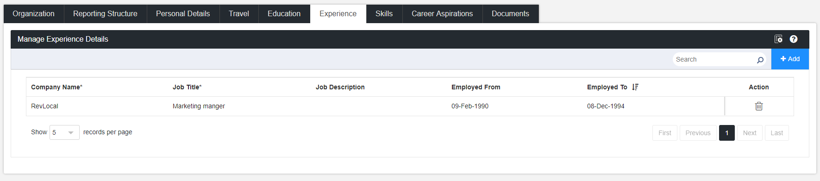

Please strike out the ones which you do not need.

|  |
| --- |
| Field Name |
| Company Name |
| Job Title |
| Job Description |
| Employed From |
| Employed To |

Also, please specify who will have the privileage to edit the information at this page? (Employee, Manager or HR)



**Skillsets & Certificates**

**Do you want to capture Skillsets and Certificates in Synergita? Yes / No**

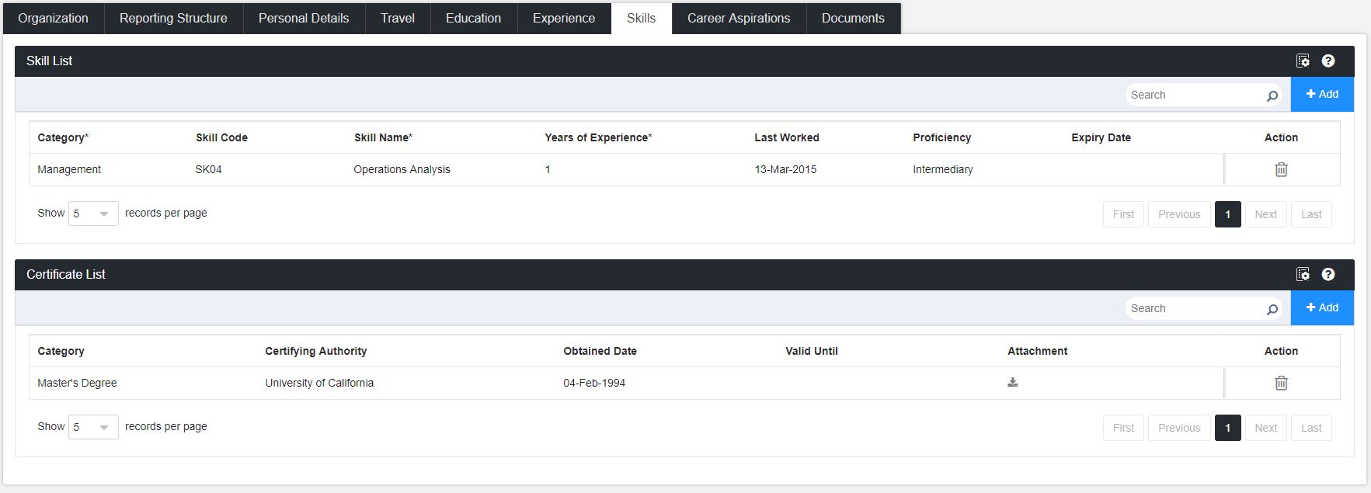

Please strike out the ones which you do not need.

|  |  |
| --- | --- |
| Field Name ( Skill Set) | Field Name ( Certificate) |
| Category | **Category** |
| Skill Name | **Certifying Authority** |
| Years of Experience | **Obtained Date** |
| Last worked on | **Valid Till** |
| Proficiency | **Attachment** |
| Expiry Date |  |

Also, please specify who will have the privileage to edit the information at this page? (Employee, Manager or HR)

Details can be shared in the attached template format:

 

**Career Aspirations**

**Do you want to capture career aspirations in Synergita? Yes / No**

Also, please specify who will have the privileage to edit the information at this page? (Employee, Manager or HR)

**Sample Questionaaires**

* Do you prefer becoming an expert in your field or broadening your knowledge of different disciplines? Why?
* What skills or knowledge would make you better at your current role?
* What are your future career goals and what do you plan to do to achieve them?
* Do you plan to pursue additional education? If so, what field would you choose?

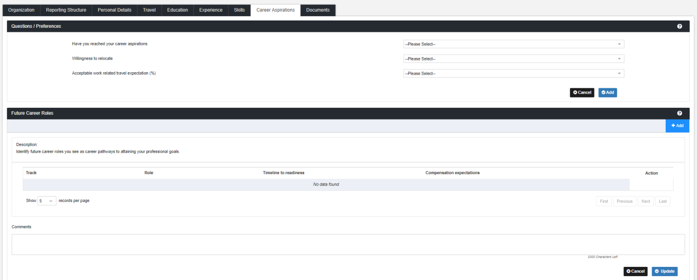

**Employee Attrition Reasons:**

**Do you keep track of the reasons why your employees are leaving your organization? Yes / No:**

If yes, what are the reasons you keep track of and mention the type as well and strike out the ones which you don’t need

|  |  |
| --- | --- |
| Attrition reasons | Type ( Voluntary, Involuntary, Rapid) |
| Absconding |  |
| Attitude |  |
| Better opportunity |  |
| Disciplinary Action |  |
| Higher Education |  |
| Marriage |  |
| Performance |  |
| Relocation |  |
| Retirement |  |

(Synergita provides default reasons like Better Opportunity, Performance, etc. This will be useful while generating the attrition report)

# 4. Synergita Perform Plus

## 4.1 360-degree driven reviews

* 360 Degree Feedback is a process in which employees receive confidential, anonymous feedback from the people who work around them. This includes the employee's manager, peers, direct reports and in some cases, customers and vendors.

**Inputs required for implementing 360 Degree Feedback:**

|  |  |
| --- | --- |
| Input | Default |
| Workflow process | Attached the sample workflow below |
| Rating scale | In case of quantitative rating, provide the rating scale – the best practice is to use the rating scale used for performance reviews. |
| Who provides the feedback? | Peers , Nominated internal/ External Reviewers |

**Here is the 360-review workflow, which can be embedded into the review cycle**

**Do you want to enable 360-degree for your Organization? YES / NO**

## 4.2 Promotion Cycle

* A **promotion** cycles are driven for the advancement of an employee's rank or position in an organizational hierarchy system. **Promotion cycle** can involve advancement in terms of designation, salary and benefits, and in some organizations the type of job activities
* This feature will help the HR/Managers in handling the employee promotion process across the organization.
* This will help organization manage the employee promotion related activities after the performance reviews in Synergita.

**Inputs required for implementing Promotion**

|  |  |
| --- | --- |
| Input | Sample |
| Feedback Form/Questions | * Please highlight the reasons for nominating the employee for promotion. * List down the unique contributions & outstanding accomplishments from the employee * Briefly explain the contribution of employee towards Organization activities * Please mention any testimonials for the employee from the customer * Explain how the employee is ready to take up the new role |
| How many levels of approvals are required? | First Level Approval - Skip Level Manager  Second Level Approval- Department Head |

**Function Flow for the Promotion process:**

**Nomination form configuration**

A well-defined nomination forms guides the manager to think through the proper reasoning for nominating the team members for promotion.

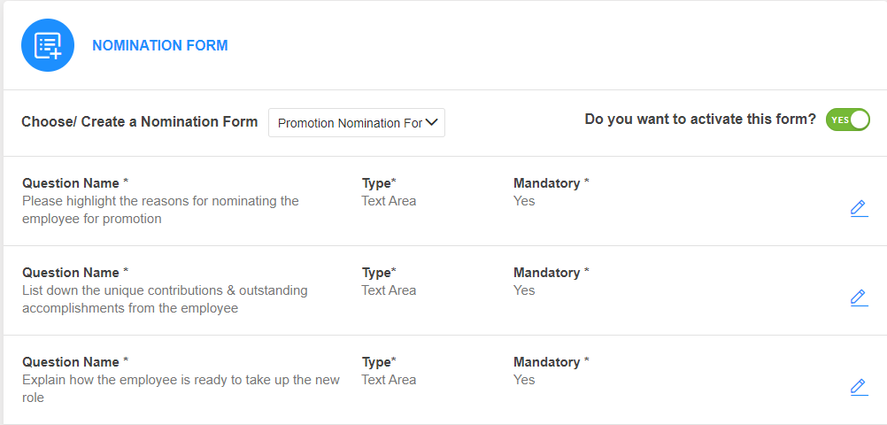

**Configure system recommendation for promotion**

System recommends employees for promotion basis several factors. Some of these factors shall be fine-tunes as per customer requirements.

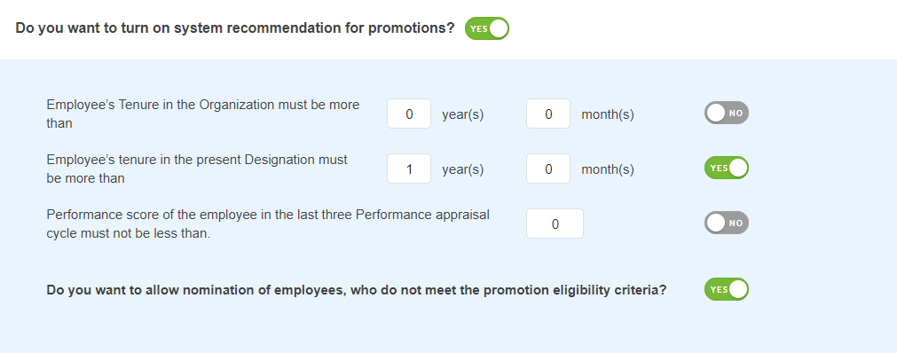

**Nominate Employees for promotion**

* Fill the nomination form
* Mention the proposed designation

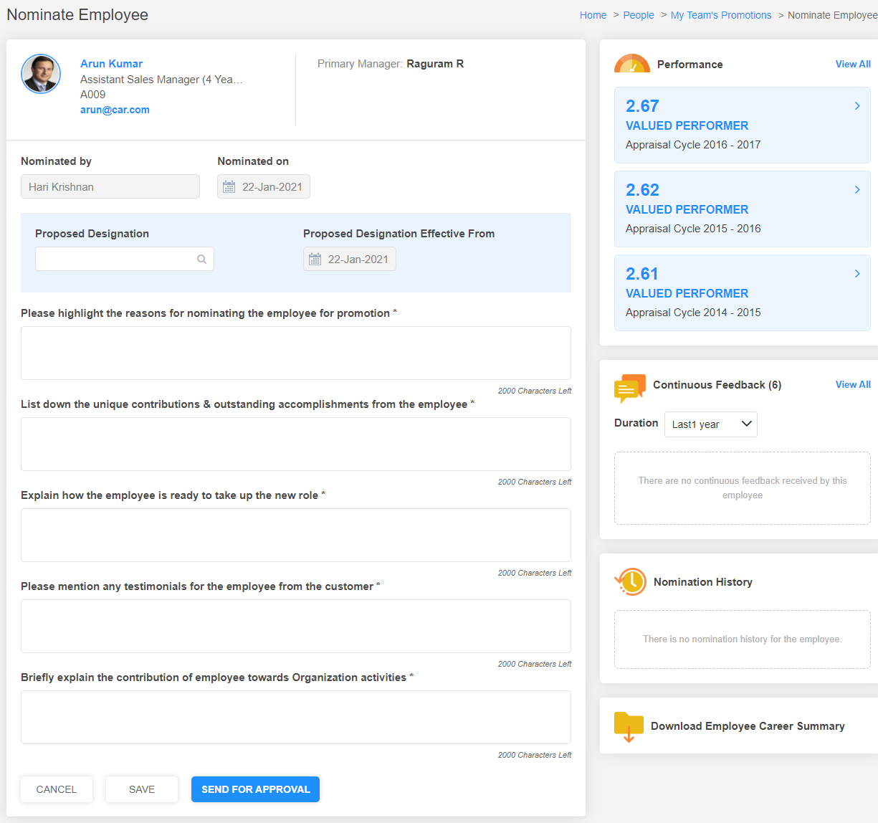

**Approve the promotion nominations**

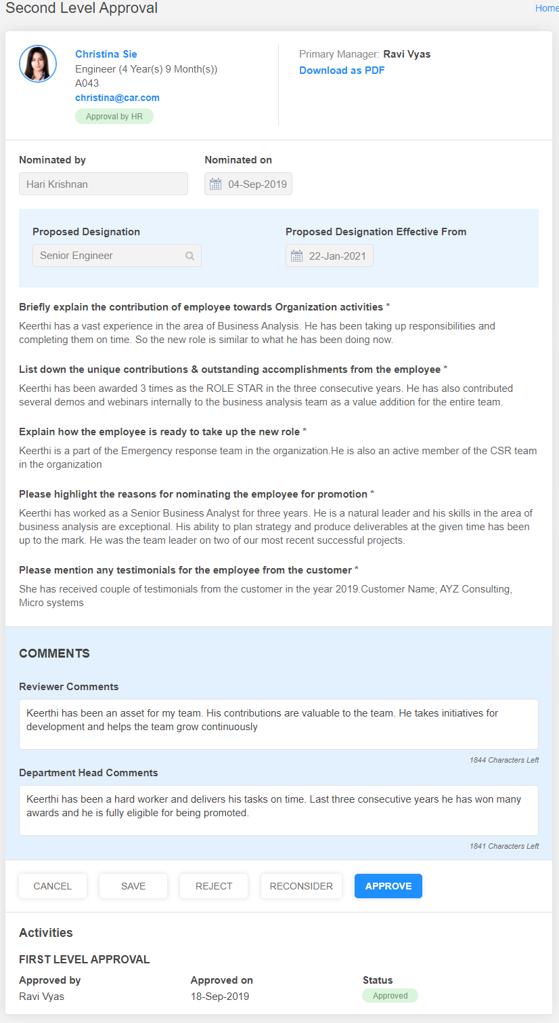

**Publish the promotions**

* Promotion is published
* The employee is notified
* The designation is updated in the employee profile

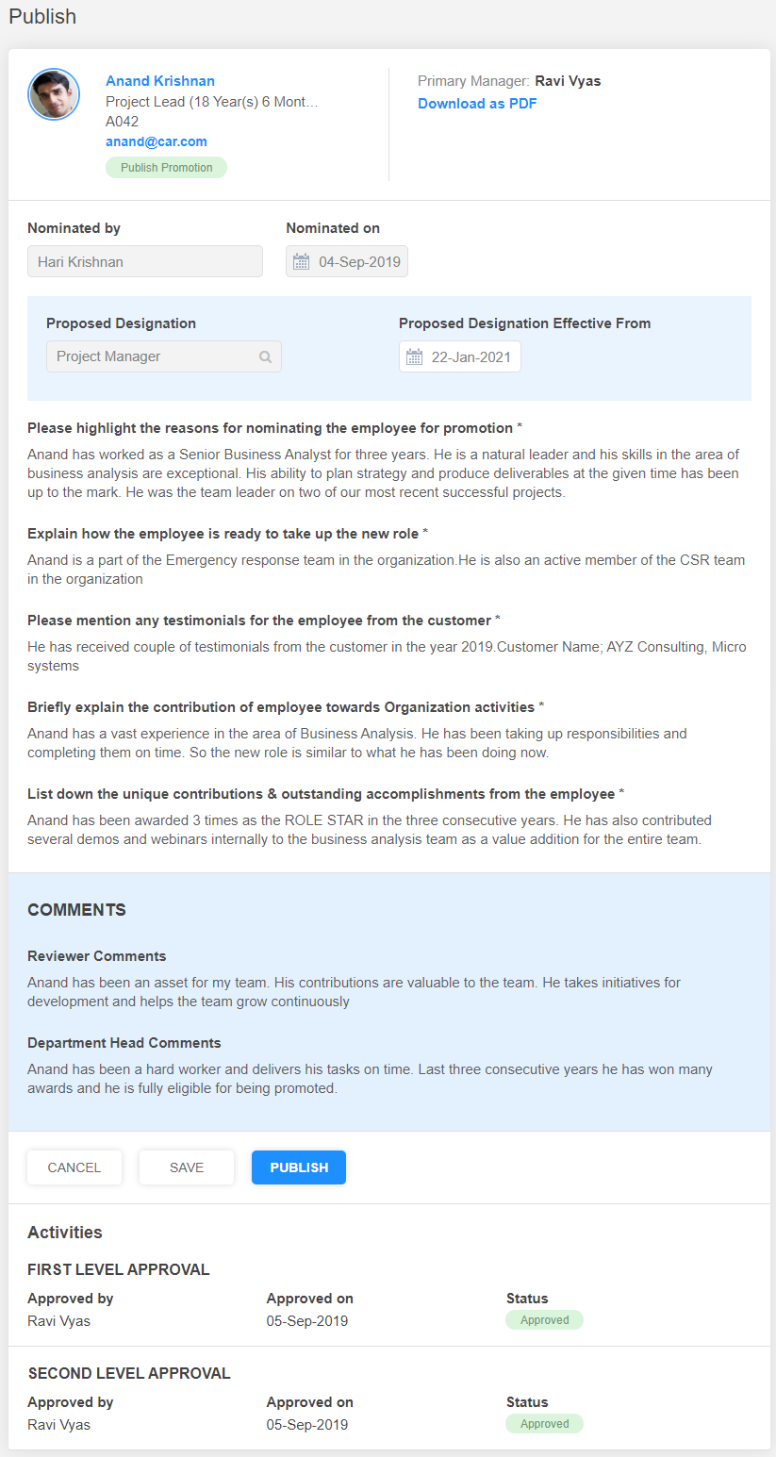

**Do you want to enable promotion feature for your Organization? YES / NO**

## 4.3 Appraisal Letter Distribution

* Salary revision letters for employees can be processed after the appraisal review cycle. In Synergita, HR can easily generate the revision letters for employees and automatically distribute the revision letters.

**Inputs required for implementing Salary Revision**

|  |  |
| --- | --- |
| Input | Default |
| Appraisal letter templates | Refer the sample |
| Do you want to enable approval step for revision? | Yes |
| Do you want to attach the letter in the email notification?  PS: If this option is not enabled, the employees can download the letter only from the system | Yes |

**Additional security/authentication to compensation module:**

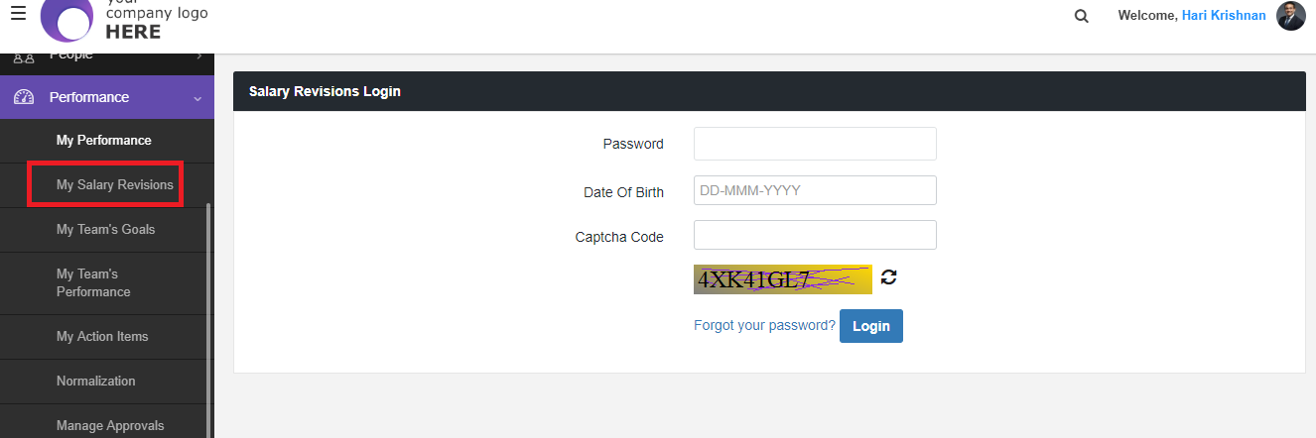

**Create appraisal letter templates**

HR shall create various templates for different purposes such as,

* Compensation revision letter
* Compensation revision letter with promotion
* Compensation revision letter with role change

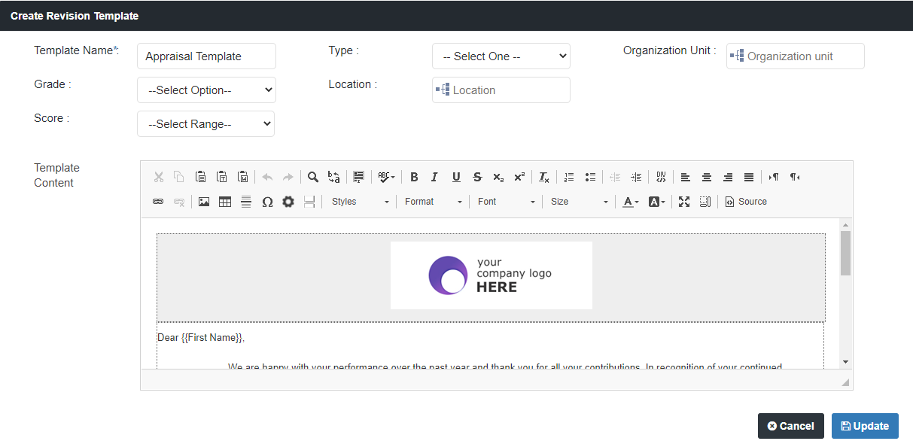

**Upload, approve & publish the letters**

HR shall upload, approve, preview and publish the letters.

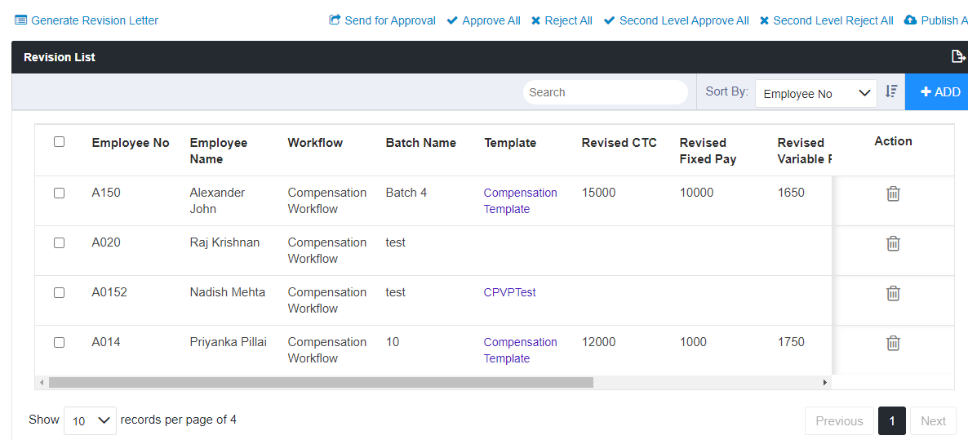

**View My Salary Revision**

Employees shall access their compensation details and download the appraisal letters.

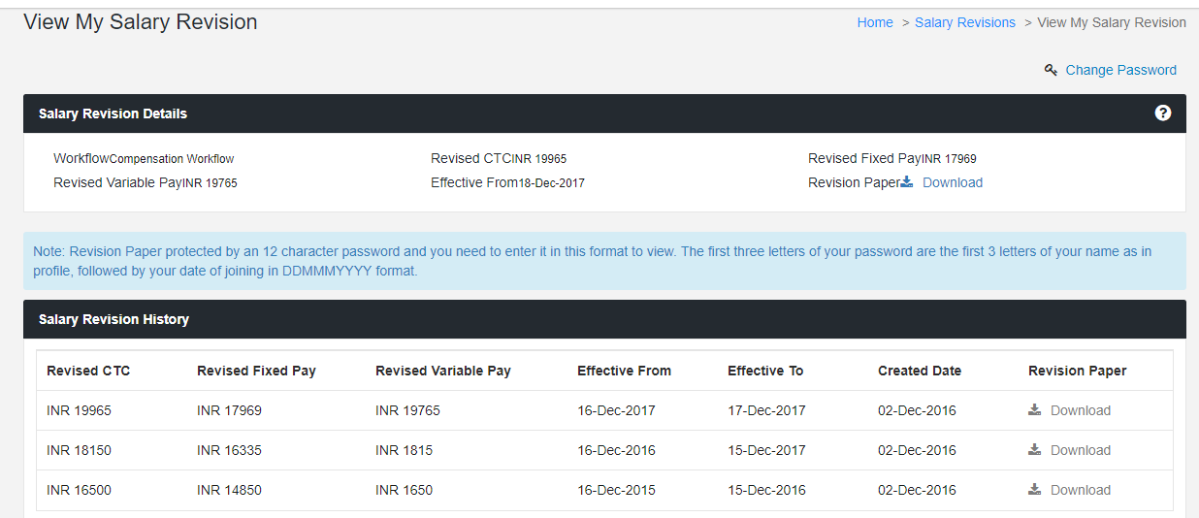

**PDF format**

The appraisal letter is generated a PDF document & dispatched to employees. This document is protected by an 12 character password and you need to enter it in this format to view. The first three letters of your password are the first 3 letters of your name as in profile, followed by your date of joining in DDMMMYYYY format.

**Sample Compensation Letter**

DD-MMM-YYYY

{{FirstName}}

{{EmployeeNumber}}

Dear {{FirstName}},

We are happy with your performance over the past year and thank you for all your contributions. In recognition of your continued contribution to Aspire and our customers, we are happy to announce the salary changes for this year. We are glad to inform that your annual total Cost-to-Company will be Rs. {{Revised CTC}}.The revised compensation is effective from DD-MMM-YYYY.

This salary increment is based on your performance, experience, designation and current pay scale. You can work with Associate Business Service (ABS), our payroll-processing provider, to structure your CTC as per your needs.

We would like to inform that you will be eligible for a performance based variable pay {{Revised Variable Pay}} which is payable at the end of the financial year (payable along with April 2016 salary) based on your overall performance in the last financial year.

The contents of this letter are privileged and private to you and you are required to maintain this information in full confidence. Any details of this letter should be discussed only with your Manager and HR. Disclosure of this information at any point in time will mean that you are disregarding the organizational code of conduct.

**Do you want to enable appraisal letters distribution feature for your Organization? YES / NO**

## 

## 4.4 HiPo Rating

Synergita allows access to identify the potential of employees and how critical are they to the Organization. Typically, this step is part of the performance review process.

HiPo Rating is calculated based on the three characteristics:  Average performance score, Potential score and Critical score of the employee. This allows the HR or the Manager to identify the best talent and find a way to actually utilize their talents.

**Potential Rating**

* The stakeholder can evaluate the potential of an employee and award a unique score based on the skill set, knowledge, abilities that he/she possesses. This gets recorded as the potential score of the employee. Determining the potential of your employees help you groom them for leadership roles and in your succession planning.

**Critical Rating**

* Similarly, the stakeholder can evaluate the criticality of an employee based on how critical he/she is to the seamless functioning of a project or team and then provide a criticality score to the employee, which also gets recorded in the system. Knowing the criticality of the employee helps you put measures in place to engage and retain to achieve sustainable growth.

**HiPo Score**

* HiPo rating denotes the true value that an employee adds to the organization, it is a weighted average of the employee’s performance, potential and criticality score. This helps the HR team and management to identify the employees who really add value to the organization. Get a head start on nurturing, engaging and retaining your future leaders with this scoring system.

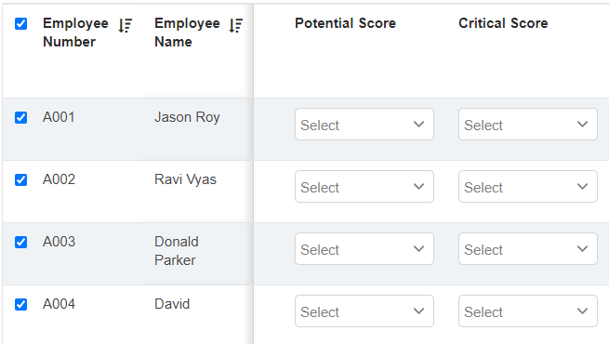

**Inputs required for implementing HiPo Rating**

|  |  |
| --- | --- |
| Input | Default |
| Weightage Distribution for Average performance score, Potential score, and Critical score | Average Performance score – 20%  Potential Score – 20%  Critical Score – 60%  ( Sum of the score weightages must be equal to 100) |
| Who will give HiPo Rating? | Skip level Manager / HR |

**Do you want to enable HiPo rating feature for your Organization? YES / NO**

# 5. Development (Employee Training)

Employee development is an all-around-the-year activity. Focus on employee development at every step of their work life. Synergita facilitates employee development initiatives with multiple touch points such as coaching and feedback, skill training recommendations and employee specific development plans.

We can also integrate with other training system to pull/push the training details.

**Inputs required for implementing Training Module**

|  |  |
| --- | --- |
| Input | Default |
| Fill in the course details in the attached template |  |
| Who will recommend training courses? | HR, Manager or Skip Level Manager |

**Do you want to enable development & Training module for your Organization? YES / NO**

# 6. Reports

Synergita provides extensive reporting capabilities in the form of Dashboards & Reports. All the reports help to build a clear perception of the performance management process and drill down in a variety of ways to focus where you want. These reports help to analyze employee performance accurately and plan for their development.

* Easy to understand graphical charts
* The reports can also be easily configured for insights

The reports are classified under two types:

* Employee Management
* Performance Management

**Note:** For more detailed, information about all the reports please refer the attached document



Please let us know the reports that needs to be enabled in the system

**Employee Management reports:** Deals with personal details

|  |  |
| --- | --- |
| Employee Management Reports | Access To ( HR, Manager, Skip Level Manager ) |
| New Hire Report |  |
| Employee Report |  |
| Employee Personal Details Report |  |
| Employee Passport Report |  |
| Employee Visa Report |  |
| Employee Education Report |  |
| Employee Work Experience Details Report |  |
| Employee Skill Set Report |  |
| Attrition Report |  |
| Employee Recommended Training Course Report |  |

**Performance Management reports**: Deals with performance details

|  |  |
| --- | --- |
| Performance Management Reports | Access To ( HR, Manager, Skip Level Manager ) |
| Employee Feedback Status Report |  |
| Employee Feedback Status Report By Raters |  |
| Performance Rating And Score Report |  |
| Continuous Feedback Summary Report |  |
| Goal Status Report |  |
| Perception Gap Analysis Report |  |
| Recommend Training Course Report |  |
| 9 Box Analysis Report |  |
| Strength And Weakness Report |  |
| Process Effectiveness Survey Report |  |
| Team Score Analysis Report |  |

# 

# 7. Email & Notification Templates

Human Resource (HR) manager can set up reminders and escalation emails to respective members. You can manage Email Notifications (Subject, body & recipient list; Activate/Deactivate email notifications)

* After the process confirmation, the implementation engineers will configure the email notification content and you can share the inputs from your end as it is customizable.

# 

# 8. Landing Page

Every user after his/her successful login will land into the home page. The home page can be customized in particular for every customer. The customer need to provide the image and content that has to be displayed in the home/landing page.

* Any announcements (or) welcome note to your organization can be added in the landing page based on your requirement.
* To the left will have the workflow finalized for the organization and to the right the HR team can give announcement about PMS and the heads to the employees about the review process
* This is customizable and below attachment has sample announcement content



# 

# 9. White Listing Email IDs & Access URLs

**Whitelist the following email addresses:**

This is to ensure that the email notifications are allowed to your domain. Synergita will send multiple emails to employees in every PMS activity for various activities.

* + - * [support@synergita.com](mailto:support@synergita.com)
* [notifications@synergita-TalentManagement.com](mailto:notifications@synergita-TalentManagement.com)

Whitelist the below IP address as well

|  |
| --- |
| IP Addresses |
| 35.154.100.53 |
| 52.66.69.252 |
| 52.66.52.226 |
| 13.126.167.138 |
| 35.154.28.139 |

Also, the following access URLs have to be white listed so that the application is accessible for your employees.

https://<YourOrganizationName>-pms.synergita.com

https://<YourOrganizationName>-pmsstage.synergita.com

Note: Check with your IT team on whitelisting the above IDs.

# 

# 10. Integration & Authentication Types

Synergita software supports various authentication and integration types through which all employee details of your organisation can be integrated which makes the data synchronization easier.

* **Single sign on ( SSO)**



**Note :** Attached files will give a detailed view on how the SSO integration works and steps involved for the same.

* **Active Directory Federation services (ADFS )**
* **Google Authentication**
* **Windows Authentication**
* **Facilitate a “Single Source of Trust” through Synergita’s Integration!**
* Synergita supports RESTful APIs
* The Request/Response format is JSON
* Authentication is based on shared secured key
* All our APIs support secure HTTPS protocols
* Data Synchronization frequency shall be set up as per customer requirements

