



Date and Version of the document

Contents

**1.Synergita Perform 2**

**2.Implementation Process 2**

**3. Implementation - Organization Structure & Employee Details 3**

**4. Synergita Perform 13**

**4.1. Appraisal Feedback forms 13**

**4.2. Goal Setting & Management 15**

**4.3 Normalization 20**

**4.4 Probation to Confirmation 21**

**4.5 30 Days Review 21**

**4.6. PIP (Performance Improvement Plan) 22**

**4.7. Past feedback 25**

**4.8. People and Performance Report 25**

**5. Email & Notification Templates 26**

**6. Landing Page 26**

**7. White Listing Email IDs & Access URLs 27**

**8. Integration & Authentication Types 28**

# Synergita Perform

Synergita perform edition focuses on the core features required for managing the employee performance right from goal setting, periodic performance reviews, monitoring the progress on employee goals and so many other features to get insights around employees’ performance across the Organization.

The purpose of the document is to define/collect the requirements to implement Synergita’s Perform module. It is intended to be a flexible, “living document” and will change and expand throughout the requirements collection phase. It is important to first determine what your performance management process will be. Providing the details below will help make your set up into a great one.

# Implementation Process

Here is a quick view of the implementation process.

**Requirements Collection Process**

Implementation team will schedule online meetings with the customers and collect the requirements and data for implementation.

|  |  |
| --- | --- |
| Session Details | Topics |
| Session 1 | Employee Talent Information, Relationship data, Employee Profile Setup, Integration & Authentication. |
| Session 2 | Understand the Feedback form, Review Process, Rating Scale, Score Calculation. Role specific access. |
| Session 3 | Normalization, Probation to confirmation, 30 day review, Performance Improvement Plan. |
| Session 4 | Reports and Email Notifications |

# 3. Implementation - Organization Structure & Employee Details

Setting up the Organization structure, employee data and group comprise the basic implementation of the product. This basic implementation is applicable for all the editions of the product.

* **Company Logo**

Share us the company logo to include in the PMS portal. Recommended dimension is 250 px (width) x 100 px (height)

* **Employee Data**

Employee data can be imported from an Excel file. Basic details like Employee Number, Name, Date of Joining (DOJ), Department, etc., can be imported together from an excel file into the system.

|  |  |
| --- | --- |
|  |  |
| Detailed Version | Minimal version |

**If you have your employee details in an Excel file (or) can export from your HRIS / ERP software, please send the file to us. We will come back to you with our questions**

* **Employee Relationship data (Employee Reporting To details)**

Defining Employee Relationship helps to relate an employee within the context of the organizational hierarchy reporting structure. This provides information to employees about who they directly report to based on the organizational hierarchy. At the same time, it also enables the Manager to search for their direct-line reports below. This feature enables to visualize hierarchy structures.

|  |
| --- |
| Relationship Name |
| Manager |
| Co-Manager (Dotted Line Reporting) |
| Skip level manager |
| Function Head/Supervisor |

* **Department Head details**

The organization head (Director, CEO,) HR, Head of HR, department wise head details can be shared which would give a detailed hierarchy structure of an employee in the system.

|  |  |  |
| --- | --- | --- |
| Department | Department head Employee Name | Department Head Employee Number |
| Finance |  |  |
| Operations |  |  |
| Business |  |  |

* **Employee Profile**



Please tick mark the ones which you want to enable and strike off the ones which you not need to be shown to employees.

|  |  |  |
| --- | --- | --- |
| List of Tabs | View access to be given  ( Employee, Manager, HR) | Edit access to be given  ( Employee, Manager, HR) |
| Organization |  |  |
| Reporting Structure |  |  |
| Personal Details |  |  |
| Travel |  |  |
| Education |  |  |
| Experience |  |  |
| Skills |  |  |
| Career Aspirations |  |  |
| Documents |  |  |

**Organization**

Following are the organization details that can be used. Please strike out the ones which you do not need.

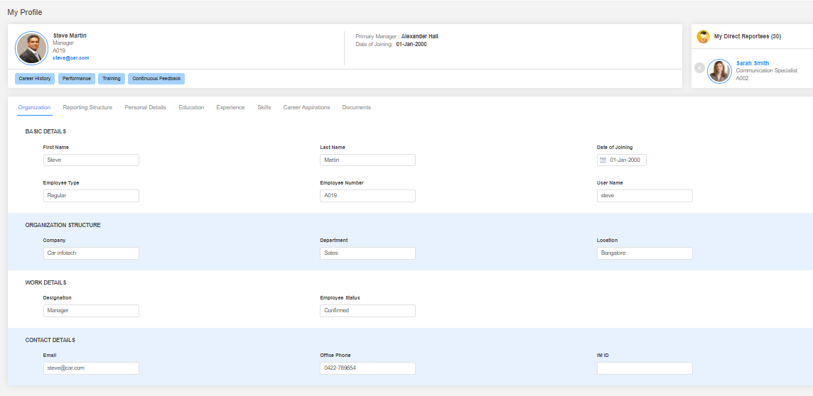

|  |  |
| --- | --- |
| Field Name | Field Name |
| First Name | **Track** |
| Last Name | **Employee status** |
| Middle Name | **Email** |
| Date of Joining | **Contact Number** |
| Employee Type | **Work Role** |
| Employee Number | **Level/Band** |
| Username | **Division** |
| Company |  |
| Department |  |
| Location |  |
| Designation |  |

**Personal Details**

**Do you want to capture personal details in Synergita? (Yes / No)**

Following are the Personal details that can be captured in Synergita. Please strike out the ones which you do not need.

|  |
| --- |
| Field Name |
| Gender |
| Nationality |
| Date of Birth |
| Primary Contact Number |
| Personal Email ID |
| Current Address |
| Permanent Address |
| Blood Group |

**Education Details**

**Do you want to capture educational details? Yes / No**

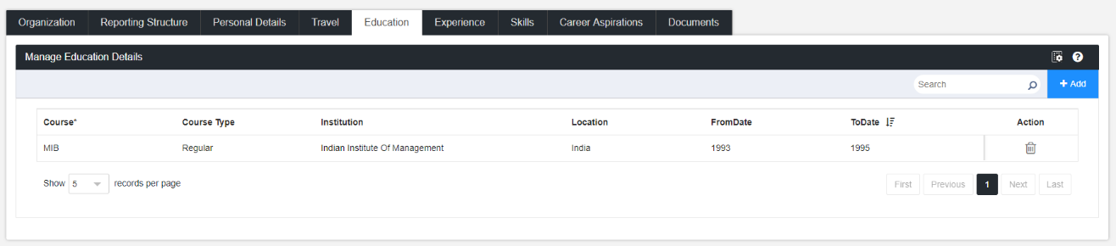

Please strike out the ones which you do not need.

Also, please specify who will have the privileage to edit the information at this page? (Employee, Manager or HR)

|  |
| --- |
| Field Name |
| Course Name |
| Course Type |
| Institution |
| Location |
| From date/To Date |

Details can be shared in the attached template format:



**Travel (Passport & Workvisa) details**

**Do you want to capture passport and work visa details in Synergita? (Yes / No)**

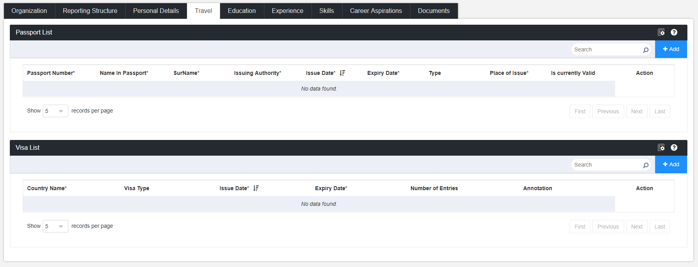

Please strike out the ones which you do not need.

|  |
| --- |
| Field Name |
| Passport Number |
| Name in Passport |
| Issuing Authority |
| Issue Date |
| Expiry Date |

Also, please specify who will have the privileage to edit the information at this page? (Employee, Manager or HR)

**Experience Details**

**Do you want to capture experience details in Synergita? (Yes / No)**

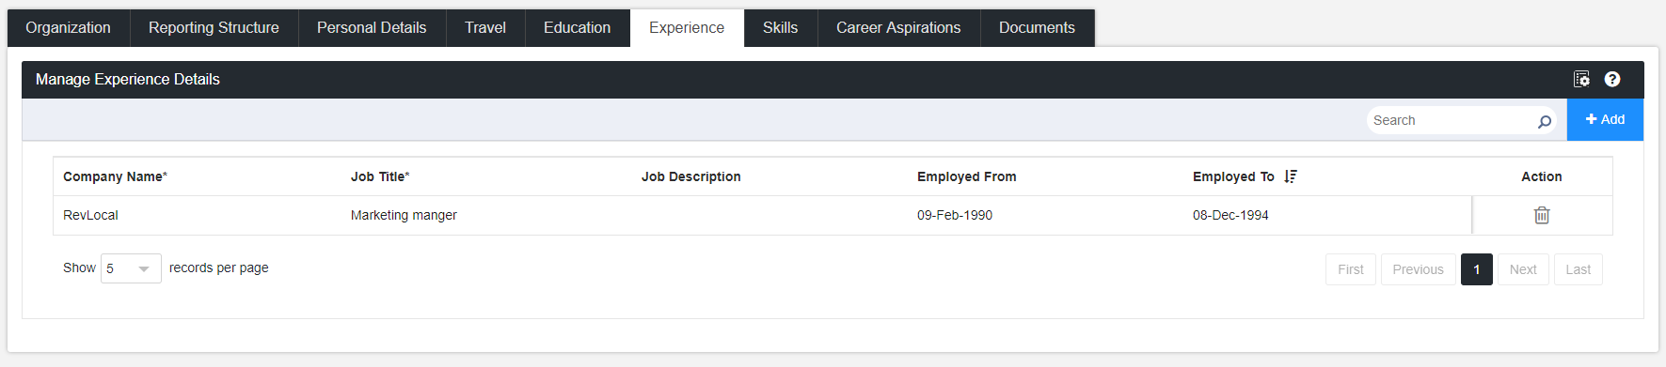

Please strike out the ones which you do not need.

|  |
| --- |
| Field Name |
| Company Name |
| Job Title |
| Job Description |
| Employed From |
| Employed To |

Also, please specify who will have the privileage to edit the information at this page? (Employee, Manager or HR)

Details can be shared in the attached template format:



**Skillsets & Certificates**

**Do you want to capture Skillsets and Certificates in Synergita? Yes / No**

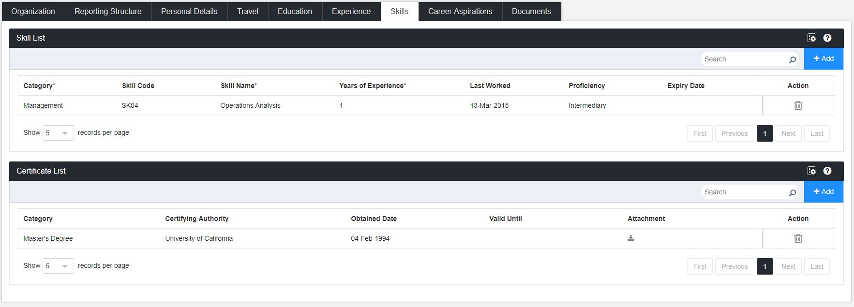

Please strike out the ones which you do not need.

|  |  |
| --- | --- |
| Field Name ( Skill Set) | Field Name ( Certificate) |
| Category | **Category** |
| Skill Name | **Certifying Authority** |
| Years of Experience | **Obtained Date** |
| Last worked on | **Valid Till** |
| Proficiency | **Attachment** |
| Expiry Date |  |

Also, please specify who will have the privileage to edit the information at this page? (Employee, Manager or HR)

Details can be shared in the attached template format:

 

**Career Aspirations**

**Do you want to capture career aspirations in Synergita? Yes / No**

**Sample Questionaaires**

* Do you prefer becoming an expert in your field or broadening your knowledge of different disciplines? Why?
* What skills or knowledge would make you better at your current role?
* What are your future career goals and what do you plan to do to achieve them?
* Do you plan to pursue additional education? If so, what field would you choose?

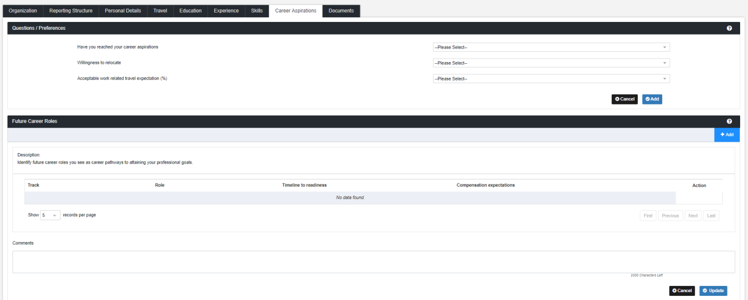

Also, please specify who will have the privileage to edit the information at this page? (Employee, Manager or HR)

**Employee Attrition Reasons:**

**Do you keep track of the reasons why your employees are leaving your organization? Yes / No:**

If yes, what are the reasons you keep track of and mention the type as well and strike out the ones which you don’t need

|  |  |
| --- | --- |
| Attrition reasons | Type ( Voluntary, Involuntary, Rapid) |
| Absconding |  |
| Attitude |  |
| Better opportunity |  |
| Disciplinary Action |  |
| Higher Education |  |
| Marriage |  |
| Performance |  |
| Relocation |  |
| Retirement |  |

(Synergita provides default reasons like Better Opportunity, Performance, etc. This will be useful while generating the attrition report)

# 4. Synergita Perform

## 4.1. Appraisal Feedback forms

Feedback forms sets the base for employee performance management. Typically, this form includes various sections including SMART goals, competencies, job skills, Organization Values, etc. These forms vary from customer to customer.

* **Sample Template for reference**



**What are weightages?**

The weightages can be distributed across the sections and the subsections weightages can be distributed as per the needs. The weightages decides the score calculation. Please review the score calculation sheet below (Score Calculation Section) and define the weightages.

How to define the feedback forms.

There are number of ways to define the feedback forms and it’s purely driven by your Organization requirements.

* One feedback form for all the employees
* One feedback form for each designation
* One feedback form for each designation + department

Synergita supports the definition of feedback forms with one or a combination of the following parameters.

* Organization units (Company, division & departments)
* Work Role
* Designation
* Location
* Level
* Track

During the goal setting step, the system will automatically pull the applicable forms for employee’s basis definition.

Please provide us your sample template and kindly provide us the following information

|  |  |
| --- | --- |
| Feedback form name (for reference) | One or more parameters (Designation, department, etc.) |
|  |  |
|  |  |

Also provide the feedback forms in excel format.

**Rating Scale**

Rating scales are used in the performance reviews. Each goal, competency, etc. are rated using these scales. The overall score is calculated basis the ratings for the individual attributes. The default scale is given below. Please modify it as per your Organization requirements.

|  |  |
| --- | --- |
| Rating Scale | Rating |
| Above Expectations | 4 |
| Met Expectations | 3 |
| Met Expectations (with reservations) | 2 |
| Below Expectations | 1 |

**Score Calculation**

Synergita supports both average score and weighted average score. The score calculation works as per the attachment



## 

## 4.2. Goal Setting & Management

**Goal setting happens during beginning of the year. It’s simple process.**

* Start > Employee Sets the Goals and sends to the manager > Manager reviews the goals
* If goals are approved,
  + End the workflow for goal setting process
* If goals are rejected, Control is sent back to the employee for setting the goals again.

Please fill your requirements in the below table.

|  |  |
| --- | --- |
| Step | Actor (Pls make if there are any changes) |
| Set Goals | Employee |
| Approve Goals | Primary Manager |
| Approval Goals (2nd level approval and it’s optional) | Skip level manager |

**Goals Management**

We all know that during the beginning of the year, we have set of goals. During the year, some may get dropped off, some may change, and some goals may be added. So, it is important to take a stock of goals and the progress every quarter and make sure that these achievements are updated continuously.

When the achievements are updated regularly, the status of goals can be tracked accurately with lead, lag, On Track status

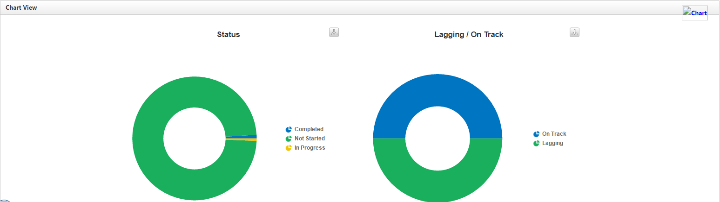

Synergita provides excellent ability to tailor your feedback form to be more focused on what you need.

**Update Achievements**

The achieved targets of employee goals shall be updated any time.

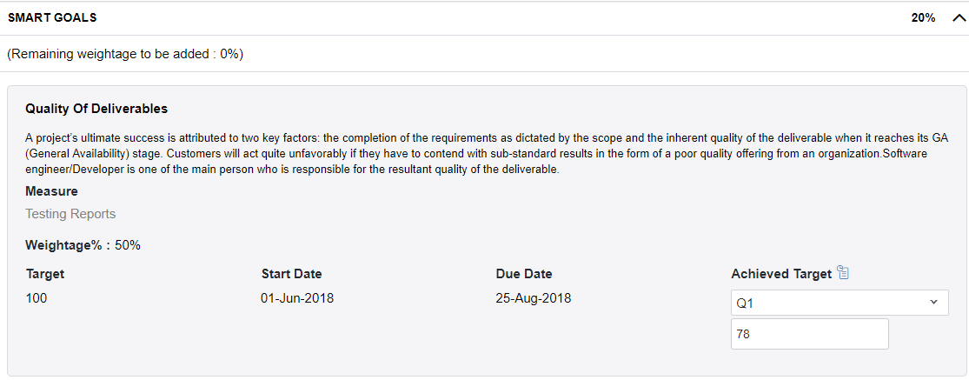

HR can bulk upload the achieved targets for employee goals. Here is the cumulative view of monthly metrics for an employee.

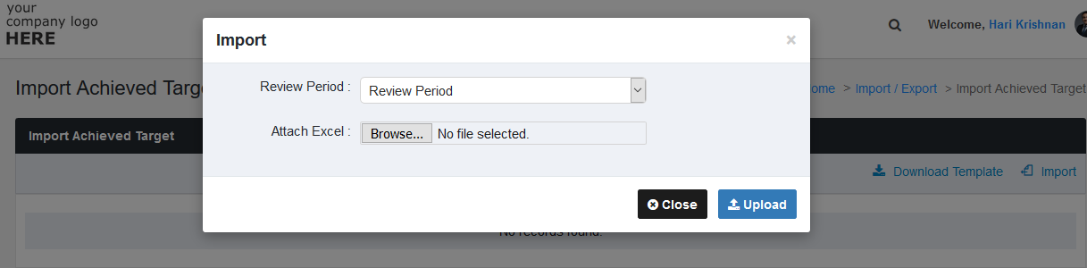

**Updating achievements during review cycle**

It is also possible to enable the option to update the achieved targets in the provide feedback step. This option shall be enabled based on customer requirements.

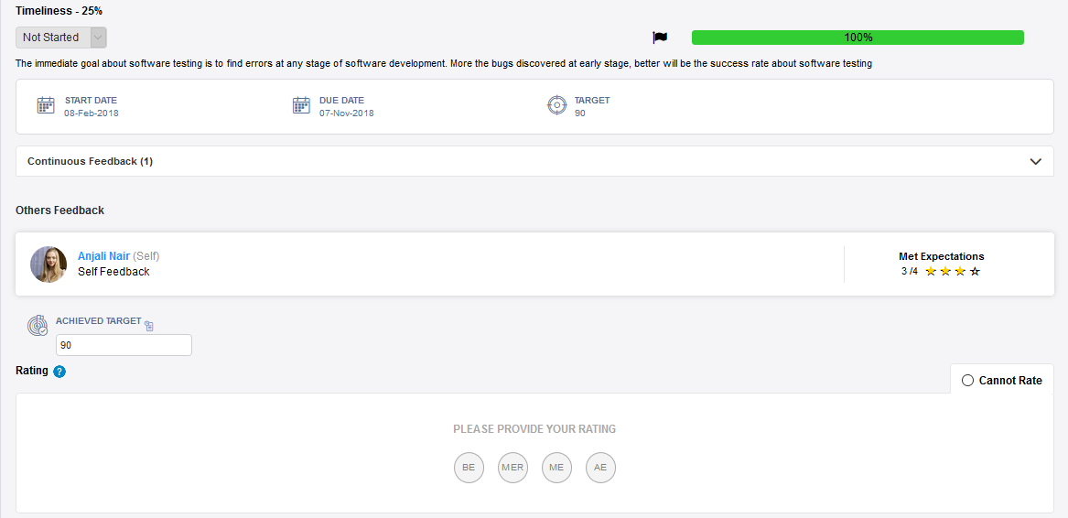

**Performance Review Process**

Performance reviews assess the employee performance and deliver more as per the definition of your feedback forms.The reviews shall be conducted quarterly or biannual or yearly based on your Organization requirements. For each instance, you have to define the process. For instance, the quarterly review process shall be brief and simple while the annual review process shall be comprehensive.

**Annual Appraisal Process in Brief**

* Start
* Employee does a self-appraisal
* Manager does the appraisal (provide feedback)
* Manager provides Recommendation and sends to the department head
* If Department Head approves,
  + Manager will publish the Manager’s feedback to the employee
  + Manager will have one-on-one meeting with the employee
* If the Department head has rejected the feedback/recommendation,
* Manager will redo the feedback and recommendation.

**Annual Appraisal Process flow Diagram**

**The product includes wide range of steps/activities; you can define the process as per your Organization requirements. Please refer the attached excel sheet for the list of available activities.**



**Recommendation form**

The recommendation form includes the final score, final rating and more fields as per your Organization requirements.

|  |  |
| --- | --- |
| Field | Requirements (Yes/No) |
| Overall Score |  |
| Final Rating |  |
| Promotion Recommendation |  |
| Overall Comment |  |
| Any other additional fields |  |

**We can also bucket the ratings as per the score range definition that works for your organization.**

|  |  |
| --- | --- |
| Bucket | Value Range |
| 1 - Does not meet minimum expectations | **0.01 - 1.49** |
| 2 - Falls short of some expectations | **1.50 – 2.49** |
| 3 - Meets all expectations | **2.50 – 3.49** |
| 4 - Exceeds some expectations | **3.50 – 4.49** |
| 5 - Exceeds all expectations | **4.50 – 5.00** |

**One-on-One Meeting**

Once the ratings are finalized the Manager/Skip Level Manager can do a One-on-One discussion with the employees and capture the discussion points

**Process Feedback**

We can get the review process feedback from the employees on the overall experience of the process they have gone through.

**Sample Questionnaires**

* Did your manager conduct the CDM meeting on time?
* Did your manager provide all the necessary inputs?
* Did your manager provide you sufficient guidance?

## 4.3 Normalization

Several Organizations still use normalization process to ensure consistency of ratings across the teams, department and at Organization level. This process also helps to ensure that the final ratings align with the ideal rating distribution, which is defined by the management team.

Here is how the ideal and actual bell curves can be analyzed and the ratings shall be changed during the normalization process.

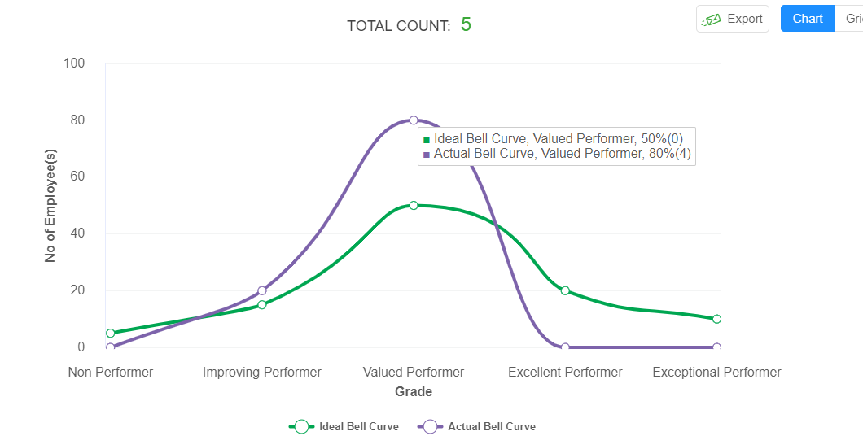

**Inputs required for the implementation:**

|  |  |
| --- | --- |
| Basic Information | Comments |
| Rating scale and rating scale description |  |
| Ideal rating distribution | Non-Performer – 5% Improving Performer – 15% Valued Performer – 40% Excellent Performer – 25% Exceptional Performer – 15% |
| Who will do the normalization in the review process? | Department Head & HR Head |

**Do you want to enable normalization feature for your organization.(Yes/No)**

## 4.4 Probation to Confirmation

**Do you have probation to confirmation evaluation process.(Yes/No)**

If yes, please provide us the template and workflow process that needs to be defined in the system.

Process can be:

* Self-Feedback
* Manager-Feedback
* HR does the confirmation Process

The feedback forms, rating scales and process shall be defined as per your requirements.

## 4.5 30 Days Review

Generally organizations conduct a 30 day review with new hires as a part of the onboarding process.

**Do you conduct 30 days evaluation process for new hire.(Yes/No)**

If yes, please provide us the template and workflow process that needs to be defined in the system.

Process can be:

* Self-Feedback
* Manager-Feedback
* HR does the confirmation Process

The feedback forms, rating scales and process shall be defined as per requirements.

## 4.6. PIP (Performance Improvement Plan)

Performance Improvement Plans enable Organizations to have an improvement plan for resources, who are lagging on certain areas.

* It’s a plan of action with timelines whereby an underperforming employee is given an opportunity to improve his performance or behavior.
* The employee is provided with specific goals or parameters against which he will be evaluated.
* The process helps in retaining an improving employee and making sure fair labor practice is followed. ​

**Inputs required for implementing PIP**

|  |  |
| --- | --- |
| Input | Default |
| PIP feedback – is it qualitative or quantitative? | Quantitative |
| In case of quantitative rating, provide the rating scale – the best practice is to use the rating scale used for performance reviews. | Rating scale used for performance reviews |
| Who provides feedback or rating in the PIP | Self & Manager |

**Functional Workflow**

**Objective Setting & plan initiation:**

* Based on the focus area, the manager can set the objectives and guidelines. Also, the forms can be predefined (standard Forms) by the management.
* These forms can be configured as required.
* ​ Objectives and ratings can be either qualitative or quantitative.
* Once the plan is defined, the same shall be started. The employee gets the email notification

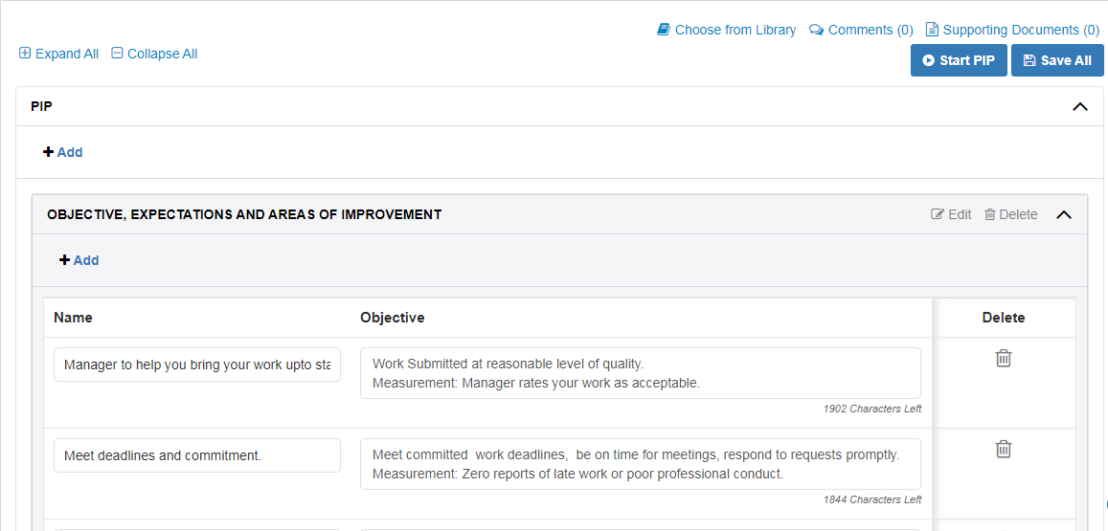

**Employee Acknowledgement & Manager Assessment:**

* Once the employee acknowledges, the PIP will start. ​
* Now employee can provide rating and justification against each objectives​
* Based on the employee’s self-rating manager will also provide rating based on his observation. ​The above two steps can be repeated until the manager find the PIP objective is satisfied.

**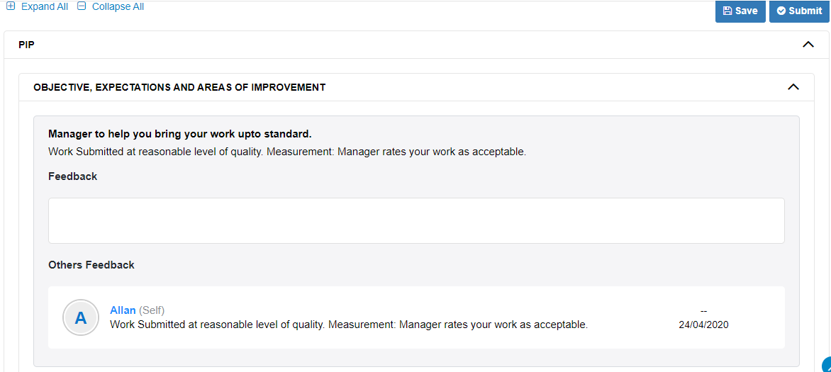****PIP status Tracking:**

* PIP Status can be tracked by the manager and the HR using the PIP Status report
* Analytical reports will display the detailed statistics of the PIP status
* PIP reports can be exported to excel

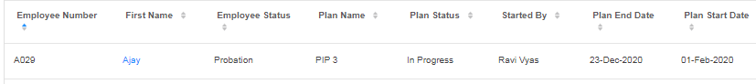

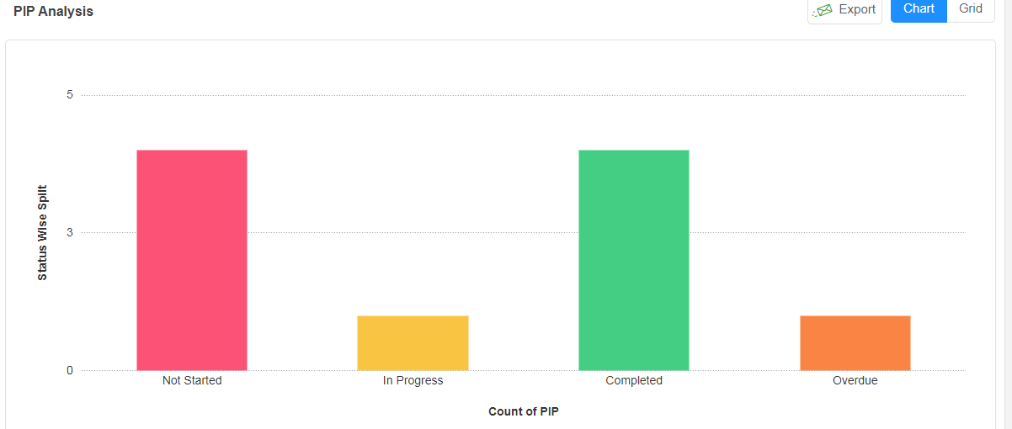

**Do you want to enable PIP process for your organization.(Yes/No)**

## 4.7. Past feedback

**Do you have past feedback (appraisal forms) of your employees? (Yes/No)**

If yes, please provide your employee feedback in PDF forms.

Please use employeenumber_Year.pdf naming convention for the file names.

## 4.8. People and Performance Report

Synergita offers an excellent set of reports to analyze the employees and their performance

The reports are classified under two types:

* Employee Management
* Performance Management

**Note:** For more detailed, information about all the reports please refer the attached document



Please let us know the reports that needs to be enabled in the system

**Employee Management reports:** Deals with personal details

|  |  |
| --- | --- |
| Employee Management Reports | Access To ( HR, Manager, Skip Level Manager ) |
| New Hire Report |  |
| Employee Report |  |
| Employee Personal Details Report |  |
| Employee Passport Report |  |
| Employee Visa Report |  |
| Employee Education Report |  |
| Employee Work Experience Details Report |  |
| Employee Skill Set Report |  |
| Attrition Report |  |
| Employee Recommended Training Course Report |  |

**Performance Management reports**: Deals with performance details

|  |  |
| --- | --- |
| Performance Management Reports | Access To ( HR, Manager, Skip Level Manager ) |
| Employee Feedback Status Report |  |
| Employee Feedback Status Report By Raters |  |
| Performance Rating And Score Report |  |
| Continuous Feedback Summary Report |  |
| Goal Status Report |  |
| Perception Gap Analysis Report |  |
| Recommend Training Course Report |  |
| 9 Box Analysis Report |  |
| Strength And Weakness Report |  |
| Process Effectiveness Survey Report |  |
| Team Score Analysis Report |  |

# 5. Email & Notification Templates

Human Resource (HR) manager can set up reminders and escalation emails to respective members. You can manage Email Notifications (Subject, body & recipient list; Activate/Deactivate email notifications)

* After the process confirmation, the implementation engineers will configure the email notification content and you can share the inputs from your end as it is customizable.

# 6. Landing Page

Every user after his/her successful login will land into the home page. The home page can be customized in particular for every customer. The customer need to provide the image and content that has to be displayed in the home/landing page.

* Any announcements (or) welcome note to your organization can be added in the landing page based on your requirement.
* To the left will have the workflow finalized for the organization and to the right the HR team can give announcement about PMS and the heads to the employees about the review process
* This is customizable and below attachment has sample announcement content 

# 7. White Listing Email IDs & Access URLs

**Whitelist the following email addresses:**

This is to ensure that the email notifications are allowed to your domain. Synergita will send multiple emails to employees in every PMS activity for various activities.

* + - * [support@synergita.com](mailto:support@synergita.com)
* [notifications@synergita-TalentManagement.com](mailto:notifications@synergita-TalentManagement.com)

Whitelist the below IP address as well

|  |
| --- |
| IP Addresses |
| 35.154.100.53 |
| 52.66.69.252 |
| 52.66.52.226 |
| 13.126.167.138 |
| 35.154.28.139 |

Also, the following access URLs have to be white listed so that the application is accessible for your employees.

https://<YourOrganizationName>-pms.synergita.com

https://<YourOrganizationName>-pmsstage.synergita.com

Note: Check with your IT team on whitelisting the above IDs.

# 

# 8. Integration & Authentication Types

Synergita software supports various authentication and integration types through which all employee details of your organisation can be integrated which makes the data synchronization easier.

* **Single sign on ( SSO)**



**Note :** Attached files will give a detailed view on how the SSO integration works and steps involved for the same.

* **Active Directory Federation services (ADFS )**
* **Google Authentication**
* **Windows Authentication**
* **Facilitate a “Single Source of Trust” through Synergita’ s Integration!**
* Synergita supports RESTful APIs
* The Request/Response format is JSON
* Authentication is based on shared secured key
* All our APIs support secure HTTPS protocols
* Data Synchronization frequency shall be set up as per customer requirements

