Date and Version of the document

Contents
1. Introduction 2
2. Implementation plan 2
3. Implementation – Organization & Employee Details 3
4. OKR (Objective Key Results) 8
4.1 OKR Process Flow: 8
4.2 Company Objectives: 9
4.3 Department or Team Objectives: 10
4.4 Employee Objectives: 11
4.5 OKR Alignment & Approval 11
4.6 Enable OKR only for a set of employees 12
4.7 OKR Configuration 13
4.8 OKR Reports 14
5. Inputs required for implementing OKR 15
6. Landing Page 16
7. White Listing Email IDs & Access URLs 17

1. Introduction

Synergita OKR edition focuses mainly on the Objective Key Results. The product includes the basic employee talent information management and OKR program for employees to define clear Objectives & Key Results to be achieved.
The purpose of the document is to define/collect the requirements to implement Synergita OKR module. It is intended to be a flexible, “living document” and will change and expand throughout the requirements collection phase.

2. Implementation plan

Here is a quick view of the implementation activities.

Requirements Collection Process
Implementation team will schedule online meetings with the customers and collect the requirements and data for implementation.
Session Details | Topic
Session 1 | Employee Talent Information, Relationship data, Employee Profile Setup, Integration & Authentication.
Session 2 | OKR Process flow, Company Objectives, Department Objectives, Employee Objectives.
Session 3 | OKR Alignment and Approval, Reports and Email Notifications

3. Implementation – Organization & Employee Details

Setting up the Organization structure, employee data and group comprise the basic implementation of the product. This basic implementation is applicable for all the editions of the product.
- Company Logo
Share us the company logo to include in the PMS portal. Recommended dimension is 250 px (width) x 100 px (height)
- Employee Data
Employee data can be imported from an Excel file. Basic details like Employee Number, Name, Date of Joining (DOJ), Department, etc., and Personal details like Date of Birth (DOB), Blood Group, Address etc., can be imported together from an excel file into the system.

- Employee Relationship data (Employee Reporting To details)
Defining Employee Relationship helps to relate an employee within the context of the organizational hierarchy reporting structure. This provides information to employees about who they directly report to based on the organizational hierarchy. At the same time, it also enables the Manager to search for their direct-line reports below. This feature enables to visualize hierarchy structures.

Relationship Name
Manager
Co-Manager (Dotted Line Reporting)
Skip level manager
Function Head/Supervisor

- Department Head details
The organization head (Director, CEO,) HR, Head of HR, department wise head details can be shared which would give a detailed hierarchy structure of an employee in the system.

Department | Department head Employee Name | Department Head Employee Number
Finance
Operations
Business

- Employee Profile
Please tick mark the ones which you want to enable and strike off the ones which you not need to be shown to employees.
List of Tabs | View access to be given  ( Employee, Manager, HR) | Edit access to be given  ( Employee, Manager, HR)
Organization
Reporting Structure
Personal Details
Travel
Education
Experience
Skills
Career Aspirations
Documents

Organization
Following are the organization details that can be used. Please strike out the ones which you do not need.
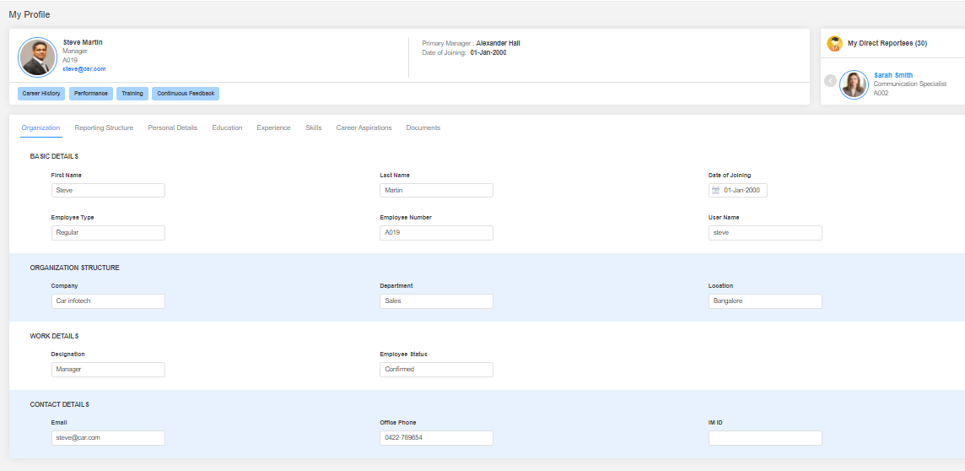
Field Name | Field Name
First Name | Track
Last Name | Employee status
Middle Name | Email
Date of Joining | Contact Number
Employee Type | Work Role
Employee Number | Level/Band
Username | Division
Company | Designation
Department
Location

Personal Details
Do you want to capture personal details in Synergita? (Yes / No)
Following are the Personal details that can be captured in Synergita. Please strike out the ones which you do not need.
Field Name
Gender
Nationality
Date of Birth
Primary Contact Number
Personal Email ID
Current Address
Permanent Address
Blood Group

Employee Attrition Reasons:
Do you keep track of the reasons why your employees are leaving your organization? Yes / No:
If yes, what are the reasons you keep track of and mention the type as well and strike out the ones which you don’t need
Attrition reasons | Type ( Voluntary, Involuntary, Rapid)
Absconding
Attitude
Better opportunity
Disciplinary Action
Higher Education
Marriage
Performance
Relocation
Retirement

(Synergita provides default reasons like Better Opportunity, Performance, etc. This will be useful while generating the attrition report)

4. OKR (Objective Key Results)

OKR is a management methodology - way to run a business by defining clear Objectives & Key Results to be achieved
Objectives – WHAT? ​
Ambitious, inspirational, direction oriented and strategic​
Key Results – HOW? ​
Objective grading, measurable, uncomfortable, connects to objective​

Benefits of OKR:
- Define and drive Organizational business objectives successfully
- Create transparent environment to drive high Performance culture and Engagement

4.1 OKR Process Flow:

4.2 Company Objectives:

- Create company objectives and add the key results for achieving the objectives. Enter the specific target & due dates for clarity on the objective and better tracking
- Also list down the initiatives to support & achieve the objectives.
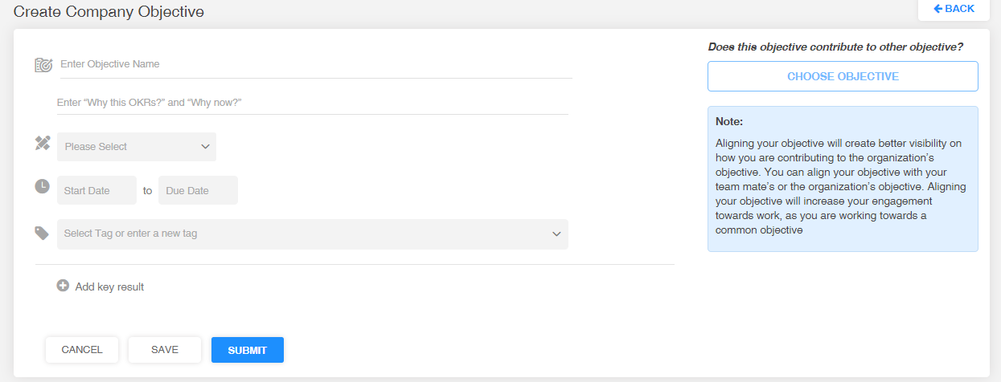
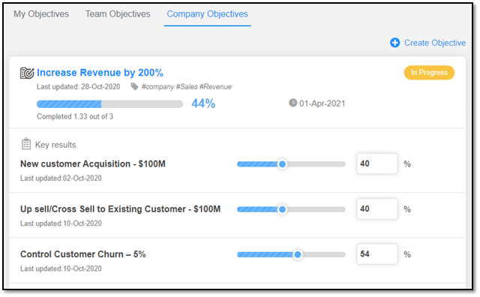

4.3 Department or Team Objectives:

- Create department /Team Objectives by mapping a team to the objectives.
- Choose OKR Champion for the respective department or team
- Align your objective with your team mate’s or the organization’s objective. Aligning your objective will increase your engagement towards work, as you are working towards a common objective.
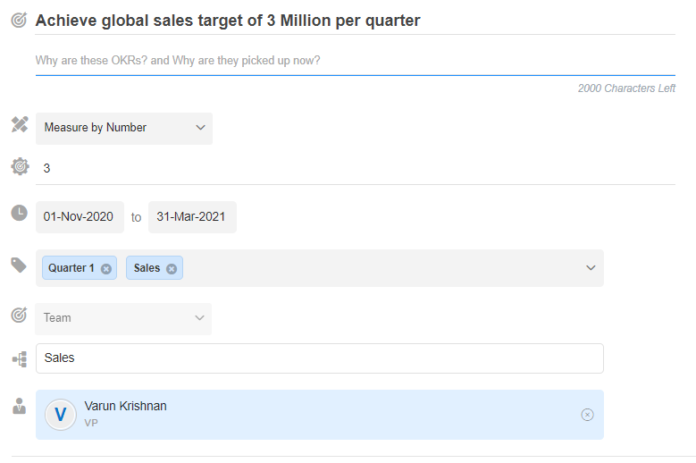

4.4 Employee Objectives:
- Create employee objectives and align the objectives with your team mate’s or the organization’s objective. Aligning your objective will increase your engagement towards work, as you are working towards a common objective.
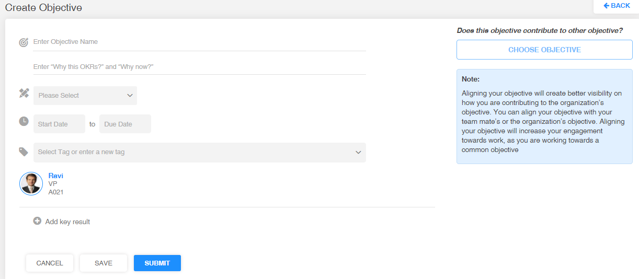

4.5 OKR Alignment & Approval

- The objectives shall be aligned with other employees’ objectives or company objectives
- The progress % of objectives are tracked basis the progress of aligned objectives
- The alignments shall be approved either by the primary manager or the OKR owner

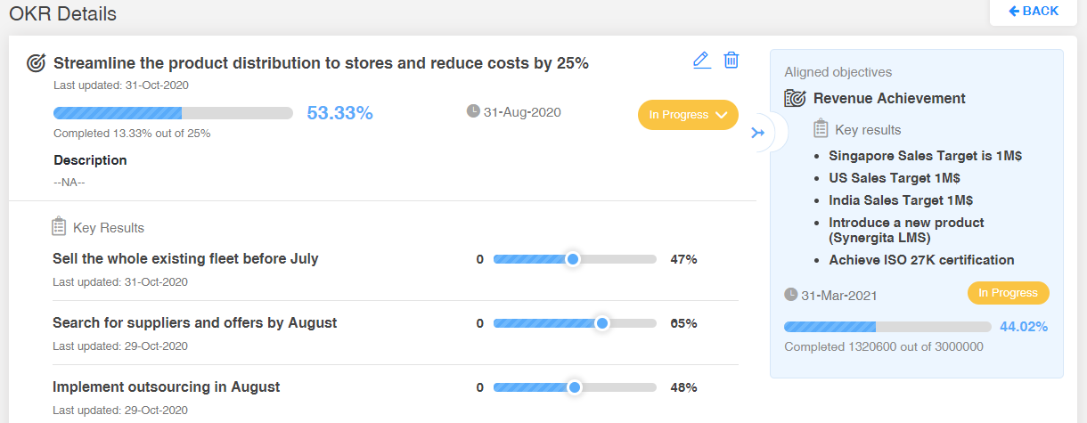
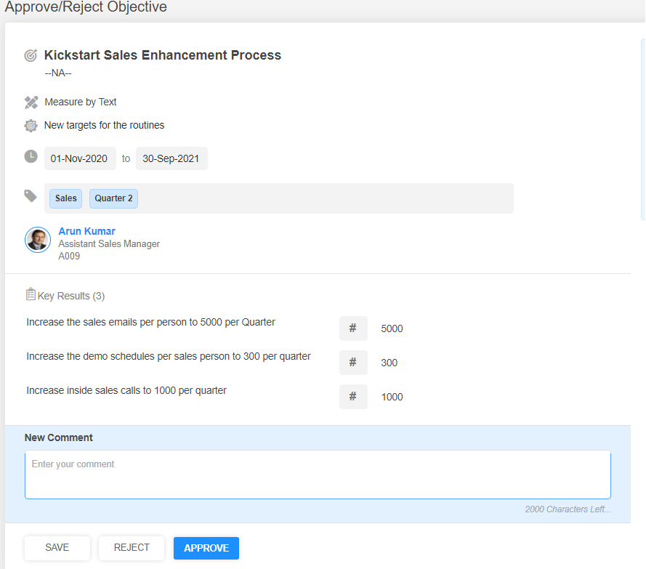

4.6 Enable OKR only for a set of employees

Do you want to enable OKR feature for your Organization? YES / NO
It’s a normal practice for the Organizations to enable OKR for a set of employees (e.g Managers and above) and have SMART goals for rest of the employees. Synergita supports this hybrid approach. You can enable OKR only for the given set of employees.
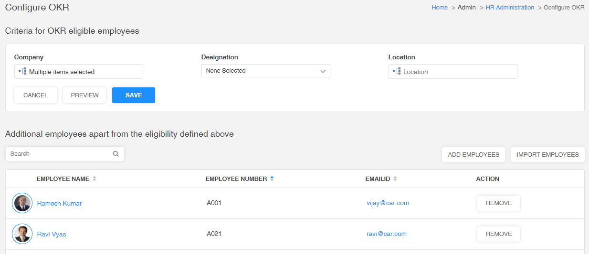

4.7 OKR Configuration

The HR shall configure the OKR module within a few steps.
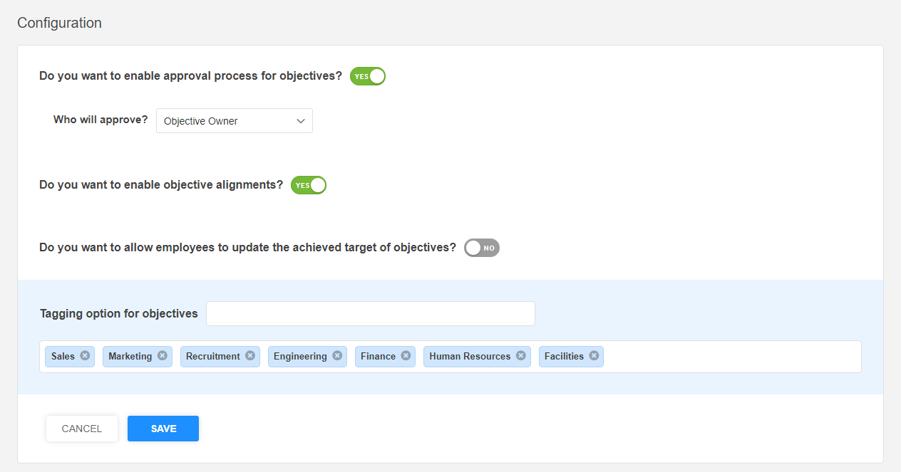

4.8 OKR Reports

- OKR Reports will provide analytical view of the summary & status of the objectives.
- HR will have the access to get the statistical data about the objectives.

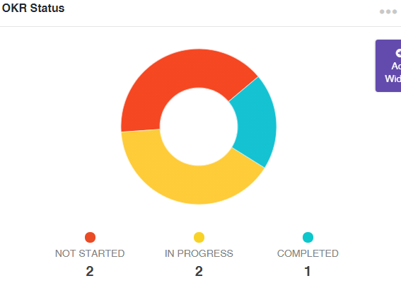
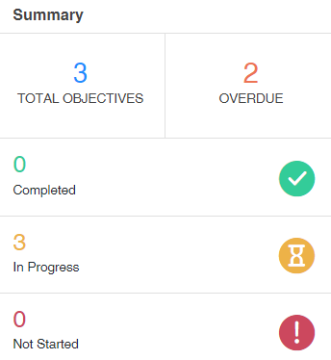
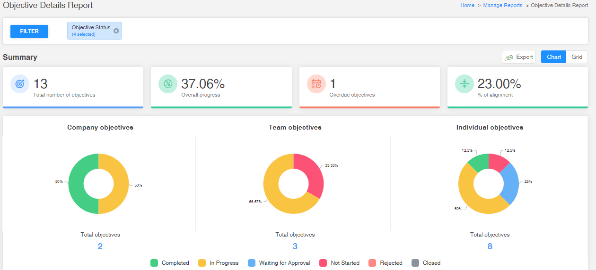

5. Inputs required for implementing OKR

Input | Default
Eligible Employees Criteria - You can provide either the list of employees or the criteria by Company, department, designation & location | All the employees
Do you want to enable primary manager approval for employee objectives? | Yes
Do you want to enable objective alignments? | Yes
Do you want to allow employees to update the achieved target of objectives?  PS: When this setting is  (A) enabled - Employees update the achieved target directly in the Objective; the progress % is computed based on the achieved target  (B) not enabled – Employee update the progress of the key results basis the system computes the progress at the Objective level. | No
List of predefined tags  PS: Tags are used to categorize the objectives across the Organization | Sales, Marketing, HR & Business

6. Landing Page

Every user after his/her successful login will land into the home page. The home page can be customized in particular for every customer. The customer need to provide the image and content that has to be displayed in the home/landing page.

- Any announcements (or) welcome note to your organization can be added in the landing page based on your requirement.

- To the left will have the workflow finalized for the organization and to the right the HR team can give announcement about PMS and the heads to the employees about the review process

- This is customizable and below attachment has sample announcement content

7. White Listing Email IDs & Access URLs

Whitelist the following email addresses:
This is to ensure that the email notifications are allowed to your domain. Synergita will send multiple emails to employees in every PMS activity for various activities.
      - support@synergita.com
- notifications@synergita-TalentManagement.com
Whitelist the below IP address as well
IP Addresses
35.154.100.53
52.66.69.252
52.66.52.226
13.126.167.138
35.154.28.139

Also, the following access URLs have to be white listed so that the application is accessible for your employees.

https://<YourOrganizationName>-pms.synergita.com
https://<YourOrganizationName>-pmsstage.synergita.com

Note: Check with your IT team on whitelisting the above IDs.

